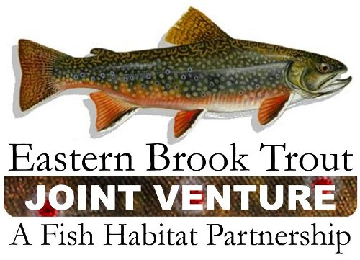
Steering Committee Conference Call

December 22, 2010
Attendees:
Bob Carline, Doug Stang, Nat Gillespie, Eric Palmer, Callie McMunigal, Steve Perry, Doug Besler, Steve Moore, Tom Sadler, Merry Gallagher, Keith McGilvray, Elizabeth Macklin, Dianne Timmins

NFHAP Updates – Steve Perry
Back in September, the FHPs rated NFHAP Board’s performance. A total of 30 individuals from 16 FHPs completed the survey. The Board’s lowest scores were in these categories: development of criteria for allocating national funding, establishing FHP performance measures, and creation of national measures of NFHAP success. The NFHAP Board held a full-day workshop this past Fall to address these needs. Outcomes include the formation of Criteria Development Committee (Steve Perry, Chair). It is charged with developing a framework for allocating funding for NFHAP, developing NFHAP performance measures, and developing national measures of NFHAP success. The Criteria Development Committee is working on a draft framework for funding and performance measures with a target date of mid-January. The draft criteria will be sent out to FHPs for review in late January. Target date for a complete product is April 2011.

In order to continue to qualify for funding, FHPs must show evidence of progress towards performance measures. These performance measures were taken from Section 3 of the NFHAP policy (FHP roles and responsibilities). Included in the funding recommendations is a proposal to allow FHPs to use a portion of their funding for operational support.

Status of FHP report – The report is just about finalized. There will be about a two-week timeframe for FHPs to review. The Writing Team hopes to send a finalized version to the Board in January for approval. The NFHAP Board is developing a roll-out plan in concert with the casting call in April.

Steering Committee Meeting Notes
SC meeting notes from October have been sent out for review. All comments received have been incorporated into the document. Notes Approved.

Steering Committee Membership List –
Callie / Keith will check on Lisa Barno’s membership status on the SC. Once final, they will post the list on the website for everyone.

Management Structure
Updates to the management structure were made at the October meeting. Doug sent out the revised draft to the SC for the 60 day review. We will vote on the new management structure document during our next conference call.

October 2010 Meeting Follow-up Items
- Research needs to all four LCCs that overlap with EBTJV - Doug is working on the research list to ensure enough information is there to convey our needs.
- Letter to USFS requesting Mark Hudy’s support / time on assessment – Tom & Doug want an estimate from Mark on what it will take to do the assessment. They will work on the letter to the USFS if Mark needs the support.
- Project Coordinates – Send coordinates to Keith for all EBTJV / NFHAP projects done to date. Keith will compile a list of projects that are still missing coordinates and seek the coordinates from the project contact.
- Update of Workgroup Accomplishments in Southern WG Format – Goal was to update this list by January 2011, but we need to wait until we name a new chair of the northern workgroup.
- Photos for Outreach Committee – Send project photos to Dianne for outreach committee use.
- Status of Banners – Banners are being printed this week and will ship soon directly to state contacts. We were able to add an additional 10 banners to the order with end of year money.
- Project Completion Reports – Doug will check with Jason on this action item. Callie needs to ensure that FWS incorporates this as a requirement into the cooperative agreements from now on. Report recently released on Measuring the Effectiveness of State Wildlife Grant Projects on the AFWA website. NFHAP should attempt to try to tie into this approach. EBTJV should review this and ensure we are working towards that goal.
- Update Conservation Strategy to reflect changes in Work Groups – Doug B. will check with Jake and ensure it is updated and posted to the website.

October 2010 Meeting Notes
Meeting notes from the October 2010 meeting were approved. Notes will be posted to the website.

Chesapeake Bay Efforts –
We are forming an ad-hoc team for Chesapeake Bay Efforts that will be necessary to work with the Chesapeake Bay Executive Order. Keith is developing a state contact list. He will send it to Jason and Rachel for review. NY will provide name of new state contact as soon as available. Anyone else that wants to be on the team should let Keith know.

2011 EBTJV NFHAP Projects
Continuing resolution was approved this week. In the mean time, FWS is moving forward with review and approval of 2011 EBTJV projects. Region 5 is in the process of preparing the list of EBTJV / ACFHP projects and forwarding them to the WO for review / approval.

Northern Workgroup Updates –
Jim sent out southern workgroup format for reporting. States are beginning to work on it.

Southern Workgroup Updates –
Jake sent out request to the few states that they still need updates from.

Outreach & Communications
Banners are done and will be shipped this week. The committee will work on the movie next. They will schedule a conference call soon.

2011 Steering Conference Call Schedule:
Steering Committee Conference Calls will be from 10am – 11am on the following dates in 2011:
March 22
June 28
September 27
December 20

Call In Number: 877-602-3943
Participant Code: 421809

