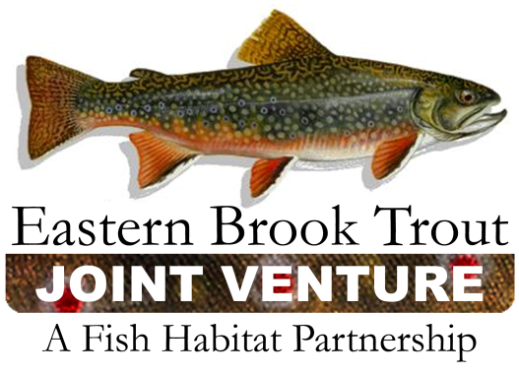

EBTJV Steering Committee
Conference Call Summary
March 20, 2012
10:00 am – Noon

Attendees: Doug Stang, Alan Heft, Jim Habera, Jake Rash, Rachel Muir, Bob Carline, Callie McMunigal, Dianne Timmins, and Keith McGilvray

- Review of Action items from December Conference Call
- Done - Tai will work with Jason, Rachel and Doug to ensure that our science needs are submitted to the AppLCC for consideration by the deadline.
- Done - Callie will forward the NFWF BBN funding notice out to partners so that they know about the opportunity and can apply on their own if they are interested.
- Presentation at East Coast Trout – Dianne will develop and give a presentation on behalf of the EBTJV. Doug will provide some recent slides / presentations to her. Dianne will check with Steve Moore for guidance / topics / etc.

- Annual Meeting Planning / Agenda Development
East Coast Update by Alan Heft – About 20 papers have been submitted to date, scattered across the topics. Deadline for paper submission has been extended to March 30th. The website for reservations and registration is not yet live, but should be available next week.

Steering Committee –Our meeting includes a half day on 13th and a full day on the 14th. Meeting will be at the Appalachian Laboratory next to Frostburg State University. Lodging is available in the dorms at the university (Sunday through Friday) or at local hotels. We should be able to start our meeting at 1pm by offering catered lunch at the Lab at noon. Callie/Keith with work with Alan to arrange for a catered lunch for ~$12-15 per person each day. Alan will provide break food / drinks.

Agenda Topics for the 13th
1pm targeted start time
General Session –
- Hudy Presentation / Status Update
- Refresher on Action Items and Group Charges for Meeting
- Presentations by Ben Letcher, Meredith Bartron, Andrew Miliken, Jean Brennan, Jose Barrios, Kurt McCoy, etc

Agenda Topics for 14th
- Northern / Southern Workgroup breakouts – 2 hrs
progress towards objectives (southern work group’s progress should be compiled and available prior to the meeting)
- Committee breakouts 2-2.5 hrs
- General Session – wrap up,

Invitational Travel – Limited funding is available to support travel by state partners. Please let Callie know ASAP if you need support.

- Multi State Conservation Grant Update – Conserving Fish Habitats from Whitewater to Bluewater
We received partial funding on our joint proposal with SARP and ACFHP. Doug emailed the latest revisions to Steering Committee members. The two primary ways we will be working together are through communications and science and data efforts. Also, there will be an evaluation of the FHPs by an intern at TNC. They will look at our structure and determine FHP strengths, weaknesses, and provide recommendations on how we can function more efficiently or effectively. Funding is also available for a joint meeting of the steering committees. The grant includes funds to hire a part-time coordinator for the EBTJV.
- FFY 2012 funding update – status, plans
Draft budget tables show EBTJV getting ~$556,800 in project funding from FWS in FY12. We hope to have FWS Director approval within the next month or two. At that time, we will be able to notify applicants of their funding status.
- Potential use of a portion of these funds to complete the status update at the catchment level
Doug presented a proposal to use a portion of our project funds to continue the catchment level assessment and climate change analysis. Rachel feels like completing this effort will foster our relationship with the Climate Science Centers and enhance our ability to leverage funding and in-kind resources for future activities. Participants noted the need to improve the quality of the assessment for the states in the northeast. A motion was made by Bob Carline to fund the assessment at no more than 20% of the annual project funds each year. The vote to approve was unanimous. We will work with Mark Hudy to get a proposal from him for this funding.

- Northern Work Group report/ update
N/A

- Southern Work Group report / update
Jake sent a request to members to provide updates on their progress and hope to receive and compile the information before the meeting in June.

Doug thanked the workgroups and members for their efforts implementing projects and tracking progress.

- Committee reports (Science / Data, Outreach, Grants and Development)
Outreach – The AppLCC has offered to build our new site and teach us how to maintain it ourselves. Diane and Callie are working with their contractor, Rose, to design and implement the new site.
- 2012 AFS meeting – EBTJV participating as invitee in two symposia
- “Experience of EBTJV in Establishing Habitat Conservation Objectives and Priorities – How It Was Done and How They Have Been Helpful” is slated to be given as part of a symposium: The NOAA Habitat Blueprint: Fisheries, marine Life, and Coastal Communities Through Habitat Conservation– Invited paper because of our success.

- “Build It and They Will Come – Fostering Participation in the Eastern Brook Trout Joint Venture” is scheduled to presented as part of a symposium: The National Fish Habitat Partnership - Building Relationships to Enhance Conservation of Aquatic Ecosystems.

- Announcements
- Temperature Network for Northeast with Ben Letcher and Mark Hudy – Meeting on 5/3/2012 in Hadley, MA. Possibly provide update to EBTJV at the annual meeting. Rachel Muir is the contact for more information.
- Northeast Climate Science Center – Development of draft science plan is underway and assistance is requested. Funding for projects in future years will be based on needs identified in this plan. Reviewers are needed for proposals. Also, an Advisory Council will be developed to be responsible for the CSC. Representation from major partners is being sought – LCCs, JVs, FHPs, etc. Rachel is requesting participation from EBTJV on both efforts – science plan / proposal review and on the Advisory Council.
- Two organizations, the Wild Trout Flyrodders and the Federation of Fly Fishers, have recently signed onto the EBTJV MOU.

- Steering Committee Conference Call Schedule
Upcoming Calls - June 5, September 18, December 18
Conference calls begin 10:00 am and generally last 1 – 1.5 hours.

