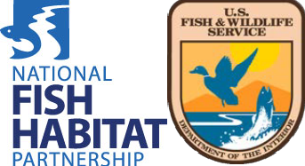

EBTJV Work Plan and Accomplishments Report
FY17 FWS NFHAP Project Funding Cycle

Fish Habitat Partnership: Eastern Brook Trout Joint Venture

Contact Person Name: Stephen Perry

Phone Number: 603-455-9704

Email Address: ebtjv.coordinator@gmail.com
Section 1. Justification for Stable Operational Support

Eastern Brook Trout Joint Venture Projects and Activities
Projects (FY2013-FY2015):
The Eastern Brook Trout Joint Venture (EBTJV) had fifteen Brook Trout projects supported by FWS-NFHAP funds between FY2013 and FY2015; twelve (12) of these projects entailed on-the ground fish habitat conservation actions while three (3) supported the EBTJV’s operational activities. Fifty-eight percent (58%) of the on-the ground fish habitat conservation projects were implemented in subwatersheds (HUC 12) the EBTJV has designated as its highest priority focal areas (subwatershed priority score = 1.30-1.66), while 8% occurred in high priority subwatersheds (subwatershed priority score = 0.66-1.29). All of the on-the ground fish habitat conservation projects addressed at least one of the five EBTJV Brook Trout key conservation actions as 100% enhanced recreational fishing for wild Brook Trout; 75% reconnected fragmented Brook Trout habitat; 33% improved Brook Trout spawning and/or early life history habitat; and, 17% preserved Brook Trout genetic diversity. From a national perspective, the twelve on-the-ground fish habitat conservation projects addressed three of four National Fish Habitat Partnership national conservation strategies, including restoring hydrologic conditions for fish, reconnecting fragmented fish habitats, and restoring water quality.
Collectively the twelve on-the-ground fish habitat conservation projects enhanced 32 stream miles of habitat; restored 30 acres of riparian habitat; and, removed 31 fish passage barriers that renewed access to 62 stream miles. The socioeconomic benefit resulting from these projects is estimated to be $52 million dollars. Additionally, using the National Fish Habitat Partnership’s economic calculator the twelve on-the-ground fish habitat conservation projects supported 70 jobs, $5.5 million dollars in total sales, $3.2 million dollars in value added, and $2.6 million dollars in income.
Activities (FY2013-FY2015)
The EBTJV completed its second range-wide Brook Trout status assessment, conducted at the catchment scale. The assessment results are serving as a basis for refining the partnerships strategic Brook Trout conservation priorities.
The EBTJV continued its strong collaborative working relationships with the Appalachian Land Conservation Cooperative (AppLCC), the North Atlantic Land Conservation Cooperative (NALCC), and the Chesapeake Bay Program in an effort to address mutual landscape level priority conservation needs. The collaborative work with the AppLCC was focused on development of a data management system for regional fish population and aquatic habitat data, decision support and web-based mapping tools, and processes for evaluating and reporting the benefits of Brook Trout conservation projects. The EBTJV involvement with the NALCC was centered on the development of decision support tools that will assist with prioritizing Brook Trout conservation actions within the Chesapeake Bay watershed, while the partnership with the Chesapeake Bay Program was aimed at aligning and coordinating priority Brook Trout conservation actions between the two entities.
The EBTJV was successful in obtaining three Multi-State Conservation Grant Program grants during this time period, providing the partnership with ~$188,000 in operational support focused on collaborative projects undertaken with the Atlantic Coastal Fish Habitat Partnership (ACFHP) and the Southeast Aquatic Resources Partnership (SARP). The purposes of these collaborative projects were to conserve fish habitat from whitewater to bluewater by advancing the coordinated implementation of strategic plans and habitat assessments of the three eastern Fish Habitat Partnerships; promoting a more cohesive implementation of the National Fish Habitat Partnership’s National Conservation Strategies across twenty-seven states; supporting and enhancing communication and outreach, steering committee operations, and scientific assessments of the three eastern Fish Habitat Partnerships; and, to provide for increased coordination within and between Partnerships, and with the National Fish Habitat Board and its Science and Data Committee.
Anticipated Projects (FY2017-FY2019)
The EBTJV Business Plan (2014-2018) identifies four priorities the partnership will emphasize during the next three years. The EBTJV intends to collaborate with key partners to: 1) eliminate fish passage barriers in catchments where habitat fragmentation is a primary threat to wild Brook Trout; 2) implement best practices in catchments where poor management of riparian and in-stream habitat are top stressors for wild Brook Trout; 3) establish a long-term monitoring program that tracks wild Brook Trout population trends across its historic eastern range; and, 4) raise awareness about the plight of wild Brook Trout among targeted audiences.
The EBTJV strategy to eliminate fish passage barriers involves establishing a priority list of catchments where anthropogenic fish passage barriers are identified as a primary threat to sustaining wild Brook Trout and facilitating the elimination of the impassable barriers within these priority catchments. Dashboard benchmarks for measuring the progress made in implementing this strategy will be the number of fish passage barriers removed from priority-designated catchments and increases in Brook Trout patch size that result from these fish barrier removals.
The EBTJV strategy to improve riparian and in-stream habitat entails establishing a priority list of catchments where poor management of riparian and in-stream habitat are identified as the primary threats to conserving wild Brook Trout and facilitating the implementation of best management practices within these priority catchments. Dashboard benchmarks for measuring the progress made in implementing this strategy will be the acreage of improved riparian habitat and stream miles of Brook Trout habitat enhanced or restored.
The EBTJV strategy to monitor wild Brook Trout populations is focused on establishing a program that further tests the effectiveness of using a series of patch-based metrics in conjunction with a framework that combines sampling a fixed set of sentinel patches annually along with a rotating sampling design for other patches. Dashboard benchmarks for measuring the progress made in implementing this strategy will be the number of States monitoring wild Brook Trout population trends and a summary of annual and multi-year trends of wild Brook Trout population abundance.
The EBTJV strategy to raises awareness about the plight of wild Brook Trout is aimed at establishing an integrated education and outreach campaign that targets anglers and outdoor/environmental reporters.
Anticipated Activities (FY2017-FY2019)
The EBTJV’s range-wide assessment of wild Brook Trout status at the catchment scale was completed during September 2015, and a draft summary report was developed so that assessment results can be processed by the EBTJV’s Science & Data and Conservation Strategy Committees in a concerted effort to incorporate the findings into the EBTJV’s Brook Trout Conservation Strategy (i.e. strategic plan).
The EBTJV continues its joint efforts to work with the AppLCC to finalize a Project Tracking Database for Brook Trout conservation projects; is collaborating with the Chesapeake Bay Program to assist in the implementation of the management strategy aimed at achieving the Brook Trout outcome identified in the Chesapeake Bay Watershed Agreement signed in June 2014; and, is working in partnership with the Atlantic Coastal Fish Habitat Partnership and Southeast Aquatic Resources Partnership to create an Eastern Aquatic Connectivity Assessment Program, which is an initiative aimed at achieving more efficient and successful fish barrier removal actions at a large regional scale (24 States).
Section 2. Accomplishments (October 1, 2012 through September 30, 2015)

- Meet the basic FHP requirements established by the National Fish Habitat Board for strategic planning and assessments

Over the previous three fiscal years, how has the FHP met basic requirements for scientific planning and habitat assessments? (Choose one and provide explanation)

- FHP has filled data gaps and refined habitat assessments, including climate change considerations, for incorporation into the Science and Data Committee’s national assessment (Level 3)

Narrative: The EBTJV completed its second status assessment of Brook Trout across the species’ historic eastern U.S. range during September 2015, which was initiated in 2011 as a result of resource managers identifying a need to have the status of Brook Trout determined at a finer scale (catchment vs. subwatershed) as well as integrating the presence of exotic trout species (rainbow trout and brown trout). The findings from this assessment were summarized in a draft report and will be used to refine the EBTJV’s Brook Trout Conservation Strategy (Strategic Plan) and modify the partnerships conservation priorities. EBTJV Brook Trout assessment data, and related data layers, are available in the Brook Trout Integrated Spatial Data and Tools, a web-based platform.

The EBTJV worked with the AppLCC to complete a riparian restoration decision support tool. The riparian restoration decision support tool allows resource managers and decision-makers to rapidly identify and prioritize areas along the banks of rivers, streams, and lakes for restoration, making these ecosystems more resilient to disturbance and future changes in climate. It also helps the conservation community invest limited conservation dollars wisely.

The EBTJV collaborated with the NALCC to complete a Brook Trout model for the Chesapeake Bay watershed that identifies and quantifies the effect of dominant stressors on the landscape, prioritizes spatially explicit conservation actions, and predicts the conservation benefits within the context of climate change. The Fish Habitat Decision Support Tool, which supports this model’s outputs, will assist the EBTJV in identifying priority areas for conservation delivery in the Chesapeake Bay watershed.

The EBTJV has and will continue to share its assessment data, modeling outputs, and decision support tools with the NFHP National Science and Data Committee so that it can help inform the Committee’s national assessment.

- Execute projects that benefit FHP priority species or priority areas

What percentage of all projects initiated in the past three fiscal years were focused on FHP defined priority species or priority areas? (Choose one)

- At least 95% (Level 3)

Complete table adding rows for additional projects as needed. Attach map with project locations and priority areas identified.

Project Title | FHP Priority Species | FHP Priority Area | Brief project description (max. 250 characters)
Upper White River Habitat Restoration Project, VT (FY13)  See Appendix Map 1 | Brook Trout | subwatershed priority scores = 0.48 & 0.56 (medium rank category) | This project addressed flood and flood recovery related habitat modifications on 4 tributaries to the Upper White River in VT by utilizing active in-stream management and design; establishing riparian buffers; and removing barriers to fish passage.
Dirt & Gravel Road Streambank Stabilization Projects, Cross Fork Subwatershed, PA (FY13)  See Appendix Map 2 | Brook Trout | subwatershed priority score = 1.35 (highest rank category) | This project focused on dirt and gravel road improvements, streambank stabilization, riparian buffer restoration, and Brook Trout habitat expansion.
Dam Removals to Reconnect Brook Trout Habitat on an Unnamed Tributary to Frankstown Branch, PA (FY13)  Link to project map:  http://bit.ly/1zW5Nu0 | Brook Trout | subwatershed priority score = 0.20 (low rank category) | This project removed two fish passage barriers to provide 1.33 miles of unrestricted fish passage to high-quality coldwater spawning and rearing habitat.
Restoration of Natural Hydrology and Habitat Complexity in the Machias Rivers, ME (FY13)  See Appendix Map 3 | Brook Trout | subwatershed priority scores = 1.58 & 1.63 (highest rank category) | This project removed 11 remnant log drive dams and added large woody material to restore fish passage, stream connectivity and natural stream processes that will passively restore cold water habitat in the tributaries of the Machias River.
Meduxnekeag Watershed In-Stream Habitat Restoration, ME (FY13)  See Appendix Map 4 | Brook Trout | subwatershed priority score = 1.56 (highest rank category) | This project restored 1.9 miles of habitat on the Meduxnekeag River mainstem and 0.25 miles of habitat on its north branch for Brook Trout.
Scott Brook Fish Passage Restoration, ME (FY13)  See Appendix Map 5 | Brook Trout | subwatershed priority score = 1.36 (highest rank category) | This project replaced an undersized and failing stream crossing on Scott Brook with an open bottom arch culvert and restored access from Big Lake to approximately 3 miles of stream habitat for Brook Trout and other native species.
Restoring Connectivity in Sunday River & Martin Stream Watersheds, ME (FY13)  See Appendix Map 6 | Brook Trout | subwatershed priority scores = 1.61 & 1.66 (highest rank category) | This project removed two fish passage barriers providing a total of six miles of connectivity in the Sunday River and Martin Stream subwatersheds.
St. Mary’s Liming, St. Mary’s River, VA (FY 13)  See Appendix Map 7 | Brook Trout | subwatershed priority score = 0.46 (medium rank category) | The streams of the Saint Mary's Wilderness have been severely compromised by atmospheric acid deposition. This project added limestone sand to the headwater streams of St. Mary's River to enhance over 12 miles of stream for Brook Trout.

Restoring Habitat Connectivity, Machias & Saint Croix River Tributary Streams, ME (FY14)  See Appendix Map 8 | Brook Trout | subwatershed priority score = 1.36-1.66 (highest rank category) | This project restores habitat connectivity on four Brook Trout streams and eliminates ongoing risks of sedimentation during culvert failure. This project also enhances the value of previous conservation investments in the upper Machias and St. Croix River watersheds.
Mill Creek (Tygart River) Stream Restoration, WV (FY14)  See Appendix Map 9 | Brook Trout | subwatershed priority score = 1.00 (high rank category) | This project utilizes principals of natural stream restoration and “chop and drop” LWD placement to address suspended tree storm damage on 6 miles of Mill Creek, WV and remediates fish passage barriers.  .
Nash Stream Restoration & Columbia Road Culverts, Odell, Coos County, NH (FY15)  See Appendix Map 10 | Brook Trout | subwatershed priority score = 1.66 (highest rank category | This project restores 6 miles of instream habitat by adding wood and other habitat elements, and replaces 2 culverts to remediate long-term habitat impairments caused by a catastrophic dam break.
Upper Shavers Fork Instream and Riparian Habitat Restoration, Randolph County, WV (FY15)  See Appendix Map 11 | Brook Trout | subwatershed priority score = 0.35 (low rank category) | This project enhances connectivity and genetic exchange within the Upper Shavers Fork and improves instream and riparian habitat.

- Execute projects that benefit FWS priority species / trust resources

What percentage of all projects initiated in the past three fiscal years addressed habitat issues for FWS priority or trust resources? (Choose one)

- 75% (Level 3)

Complete table adding rows for additional projects as needed.

Project Title | FWS Region | State | Primary Species or Resources Benefitted | FWS Priority or Trust Resources (if neither, enter N/A)
Upper White River Habitat Restoration Project, VT (FY13) | Region 5 | VT | Brook Trout | Brook Trout
Dirt & Gravel Road Streambank Stabilization Projects, Cross Fork Subwatershed, PA (FY13) | Region 5 | PA | Brook Trout | Brook Trout
Dam Removals to Reconnect Brook Trout Habitat on an Unnamed Tributary to Frankstown Branch, PA (FY13) | Region 5 | PA | Brook Trout | Brook Trout
Restoration of Natural Hydrology and Habitat Complexity in the Machias Rivers, ME (FY13) | Region 5 | ME | Brook Trout | Brook Trout
Meduxnekeag Watershed In-Stream Habitat Restoration, ME (FY13) | Region 5 | ME | Brook Trout | Brook Trout
Scott Brook Fish Passage Restoration, ME (FY13) | Region 5 | ME | Brook Trout | Brook Trout
Restoring Connectivity in Sunday River & Martin Stream Watersheds, ME (FY13) | Region 5 | ME | Brook Trout | Brook Trout
St. Mary’s Liming, St. Mary’s River, VA (FY13) | Region 5 | VA | Brook Trout | Brook Trout
Restoring Habitat Connectivity, Machias & Saint Croix River Tributary Streams, ME (FY14) | Region 5 | ME | Brook Trout | Brook Trout
Mill Creek (Tygart River) Stream Restoration, WV (FY14) | Region 5 | WV | Brook Trout | Brook Trout
Nash Stream Restoration & Columbia Road Culverts, Odell, Coos County, NH (FY15) | Region 5 | NH | Brook Trout | Brook Trout
Upper Shavers Fork Instream and Riparian Habitat Restoration, Randolph County, WV (FY15) | Region 5 | WV | Brook Trout | Brook Trout

- Project Completion and Success (90%)

What percentage of projects, funded in whole or in part, with FWS NFHAP funds in the past three to five fiscal years have been completed consistent with the project design? (Choose one) See attachment further guidance on responding to this criterion

- 80% of projects completed in the past five years (Level 3)

Complete table adding rows for additional projects as needed. All projects that received fiscal year (FY) 2011 through 2015 FWS NHFAP project funds should be listed in the table below. In the Completion Date column, enter the date that the project was completed (use the following date format, mm/dd/yyyy). For projects that are on-going or incomplete, enter N/A.

Project Title | Accomplishments # | Completion Date | Project completed according to design (Yes/No and explain response, max 250 characters)
Carloe Brook Fish Passage Restoration Project, Washington County, ME (FY11) | 53371-A-179 | During or before FY13 | Yes; personal communication from FWS Project Officer Scott Craig.
Brook Trout Restoration in the Chattahoochee National Forest, GA (FY11) | 42330-A-047 | During or before FY13 | Yes; personal communication from Project Applicant Michael Joyce (USDA Forest Service). mjoyce@fs.fed.us
Removal of Illegally Introduced and Missed Rainbow Trout from Lynn Camp Prong, Great Smoky Mountain National Park, TN (FY11) | 42216-A-025 | During or before FY13 | Yes; personal communication from Project Applicant Steve Moore (National Park Service). matt_kulp@nps.gov
Restoring Habitat Connectivity in Machias and Saint Croix River Tributary Streams, ME (FY11) | 53371-A-181 | During or before FY13 | Yes; personal communication from FWS Project Officer Scott Craig.
Marshall Brook Culvert Replacement, Hancock County, ME (FY11) | 53371-A-178 | During or before FY13 | Yes; personal communication from FWS Project Officer Scott Craig.
Thunder Brook Dam Removal, MA (FY11) | 53340-A-048 | During or before FY13 | Yes; personal communication from FWS Project Officer Martha Naley
Upper Shavers Fork Aquatic Passage Project, WV (FY11) | 53374-A-040 | During or before FY13 | Yes; personal communication from FWS Region 5 NFHP Coordinator Callie McMunigal.
Enhancing Connectivity in the Ash-Black Rock Subbasin of the WB Narraguagus River, ME (FY11) | 53371-A-180 | During or before FY13 | Yes; personal communication from FWS Project Officer Scott Craig.
Restoration of Native Charr in Big Wadleigh Pond, ME (FY12) | 53371-A-188 | During or before FY14 | Yes; personal communication from FWS Project Officer Scott Craig.
Jam Black Brook Culvert Replacement, ME (FY12) | 53371-A-187 | During or before FY14 | Yes; personal communication from FWS Project Officer Scott Craig.
Nash Stream Restoration b/t Emerson Brook & Long Mountain Brook, NH (FY12) | 53340-A-055 | During or before FY14 | Yes; personal communication from FWS Project Officer Martha Naley
Culvert Replacement and Instream Habitat Restoration in the Nulhegan River VT (FY12) | 53330-A-048 | During FY14 | Yes; personal communication from FWS Project Officer Jaime Masterson.
Removal of Two Dams in the Wetmore Run Watershed, PA (FY12) | 52230-A-043 | During or before FY14 | Yes; personal communication from FWS Project Officer Thomas Kehler.
Wolf Laurel Branch Culvert Replacement, NC (FY12) | Need # from R4 | During or before FY14 | Yes; personal communication from Project Applicant Jason Farmer (USDA Forest Service) jfarmer@fs.fed.us
Brook Trout Catchment Scale and Climate Change Vulnerability Assessment (FY12) | 53374-A-044 | During FY15 | Personal communications with FWS Region 5 NFHAP Coordinator Callie McMunigal.
Oats Run Fish Passage Project, Upper Shavers Fork, WV (FY12) | 53374-A-043 | 8/2014 | Yes; personal communication from FWS project Officer Keith McGilvray
Upper White River Habitat Restoration Project, VT (FY13) | Multiple Numbers | During FY15 | Yes; personal communication from FWS Project Officer Jaime Masterson.
Dirt & gravel road, streambank stabilization projects, Cross Fork Subwatershed, PA (FY13) | 52230-A-049 | During FY14 | Yes; personal communication with FWS Project Officer Thomas Kehler.
Dam Removals to Reconnect Brook Trout Habitat on an Unnamed Tributary to Frankstown Branch, PA (FY13) | 52230-A-050 | During FY15 | Yes; personal communication with FWS Project Officer Thomas Kehler.
Restoration of Natural Hydrology and Habitat Complexity in the Machias Rivers, ME (FY13) | 53371-A-194 | During FY14 | Yes; personal communication from FWS Project Officer Scott Craig.
Meduxnekeag Watershed In-Stream Habitat Restoration, ME (FY13) | 53371-A-193 | 12/30/14 | Yes, personal communication from FWS Region 5 NFHAP Coordinator Callie McMunigal ( FWS Project Officer Scott Craig).
Scott Brook Fish Passage Restoration, ME (FY13) | 53371-A-190 | During FY14 | Yes; final project report distributed by FWS Project Officer Scott Craig.
Restoring Connectivity in Sunday River & Martin Stream Watersheds, ME (FY13) | 53371-A-189 | NA | Personal communication from FWS Region 5 NFHAP Coordinator Callie McMunigal ( FWS Project Officer Scott Craig).
St. Mary’s Liming, St. Mary’s River, VA (FY13) | 53374-A-049 | During FY14 | Yes; personal communications from FWS Region 5 NFHAP Coordinator Callie McMunigal (FWS Project Officer Keith McGilvray)
EBTJV Operational Support - Interactive Database & Mapper and Travel Support (FY13) | 53374-A-050 | During FY15 | Yes; personal communications from FWS Region 5 NFHAP Coordinator Callie McMunigal.
Restoring Habitat Connectivity, Machias & Saint Croix River Tributary Streams, ME (FY14) | 53371-A-206 | 9/30/15 | Yes; Personal communication from FWS Region 5 NFHAP Coordinator Callie McMunigal ( FWS Project Officer Scott Craig).
Mill Creek (Tygart River) Stream Restoration, WV (FY14) | 53374-A-053 | 12/30/15 | Yes: Personal communications from FWS Region 5 NFHAP Coordinator Callie McMunigal.
EBTJV Coordination and Operations (FY14) | 53374-A-043 | 12/30/15 | Yes; Personal communication from FWS Region 5 NFHP Coordinator Callie McMunigal.
Nash Stream Restoration & Columbia Road Culverts, Odell, Coos County, NH (FY15) | 53340-A-084 | NA | Personal communication from FWS Region 5 NFHP Coordinator Callie McMunigal.
Upper Shavers Fork Instream and Riparian Habitat Restoration, Randolph County, WV (FY15) | 53374-A-058 | NA | Personal communication from FWS Region 5 NFHP Coordinator Callie McMunigal.
EBTJV Coordination and Operations (FY15) | 53374-A-059 | NA | Personal communication from FWS Region 5 NFHP Coordinator Callie McMunigal.

- Monitoring and Evaluation

What percentage of all projects initiated in the past three fiscal years included a monitoring and evaluation plan? (Choose one)

- 90% (Level 3)

Complete table adding rows for additional projects as needed.

Project Name | Brief Monitoring & Evaluation Plan Description (max. 250 characters)
Upper White River Habitat Restoration Project, VT (FY13) | The Green Mountain National Forest maintains a long-term fish monitoring station on the West Branch to evaluate physical and biological conditions on an annual basis. The FWS will conduct pre-Project monitoring above and below each culvert site as well as post-Project monitoring for at least 2 years following Project implementation.
Dirt & Gravel Road Streambank Stabilization Projects, Cross Fork Subwatershed, PA (FY13) | To monitor the effectiveness in terms of fine sediment contribution to the adjacent stream, Brook Trout spawning habitat surveys will be conducted upstream and downstream of the selected project sites. Periodic inspection of the riparian buffer projects will result in clearing away any non-native vegetation that may inhibit the growth of the newly planted native trees and shrubs.
Dam Removals to Reconnect Brook Trout Habitat on an Unnamed Tributary to Frankstown Branch, PA (FY13) | Visual monitoring of stream conditions will be conducted post-removal to verify project performance and success. A stream survey will be conducted at approximately one year and three years after construction completion to evaluate the effectiveness of the project on achieving the stated objective.
Restoration of Natural Hydrology and Habitat Complexity in the Machias Rivers, ME (FY13) | The Gulf of Maine Stream Barrier Removal Monitoring Protocols will be used for pre-and post-restoration monitoring. Longitudinal profiles and benchmarked transects will be surveyed prior to dam removal and again post-removal following a year of high water following through the site.
Meduxnekeag Watershed In-Stream Habitat Restoration, ME (FY13) | Annual standardized fish, habitat and geomorphic survey protocols above, within and below the project sites will be implemented for two years. ACOE will use these same protocols to monitor the project sites for one additional year as part of a larger Meduxnekeag Watershed Management Planning Project.
Scott Brook Fish Passage Restoration, ME (FY13) | Brook Trout survey data will be collected pre and post restoration.
Restoring Connectivity in Sunday River & Martin Stream Watersheds, ME (FY13) | The Lively Brook project will be monitored during construction at sites for compliance with best management practices and permitting guidelines. Fishery responses to the project will be evaluated for a minimum of 2 years after construction (three years including the construction year).
St. Mary’s Liming, St. Mary’s River, VA (FY13) | Water chemistry will be monitored throughout the watershed following project implementation as part of a cooperative agreement between James Madison University and the Forest Service. Fish and macroinvertebrates will be monitored at two permanent sampling stations every year and six permanent sampling stations every other year.
Restoring Habitat Connectivity, Machias & Saint Croix River Tributary Streams, ME (FY14) | Post project monitoring will entail electro-fishing to determine brook trout size, condition and fish species relative abundance, and a follow-up comparison will be performed 3-5 years after the project has been completed.
Mill Creek (Tygart River) Stream Restoration, WV (FY14) | This project will benefit from pre-project surveys, assessments, and detailed mapping. Biannually, the 6 mile project area will be monitored with comparisons to pre-restoration conditions in terms of both geomorphic and fishery conditions.
Nash Stream Restoration & Columbia Road Culverts, Odell, Coos County, NH (FY15) | The project entails a long-term monitoring of aquatic habitat and fish populations. Fish surveys will be conducted to at least 2020 and geomorphic assessments will continue until after the restoration activities are completed.
Upper Shavers Fork Instream and Riparian Habitat Restoration, Randolph County, WV (FY15) | WVDNR has funded WVU to conduct a watershed scale monitoring effort through 2017. The project area is included in that monitoring effort.

- Leveraging of FWS Project Funds

Over a three year period the FHP leveraged FWS NFHAP funding by a ratio of (Choose one). See attachment for further guidance on responding to this criterion:

- At least 3:1 (Level 3)

Complete table adding rows for additional projects as needed.
Project Name | FWS NFHAP Project Funds | Non-FWS Contributions | Other Contributions | Total Project Costs | Funding Partners
Upper White River Habitat Restoration Project, VT (FY13) | $50,000 | $604,800 | $123,429 | $778,229 | FEMA  USDA Forest Service  VT Fish and Wildlife  Town of Rochester  White River Partnership  Private Landowners  FWS
Dirt & Gravel Road Streambank Stabilization Projects, Cross Fork Subwatershed, PA (FY13) | $45,000 | $266,562 | $19,286 | $330,848 | NFWF  Richard King Mellon Fund  Chesapeake Bay Trust  PA DEP
Dam Removals to Reconnect Brook Trout Habitat on an Unnamed Tributary to Frankstown Branch, PA (FY13) | $25,000 | $80,500 | $10,714 | $116,214 | American Rivers  PA Fish and Boat Commission  Hollidaysburg Borough
Restoration of Natural Hydrology and Habitat Complexity in the Machias Rivers, ME (FY13) | $33,000 | $23,441 | $30,643 | $87,084 | Maine DMR  Downeast Lakes Land Trust  Project SHARE  Washington Academy  University of Maine – Machias  FWS

Meduxnekeag Watershed In-Stream Habitat Restoration, ME (FY13) | $13,499 | $124,300 | $5,785 | $143,584 | HBMI  NRCS  ACOE  Maine Inland F & W  Monticello F & G Club  SASWCD
Scott Brook Fish Passage Restoration, ME (FY13) | $20,000 | $19,500 | $9,071 | $48,571 | Maine Inland F & W  Maine Forest Service  Wagner Forest Management  FWS
Restoring Connectivity in Sunday River & Martin Stream Watersheds, ME (FY13) | $36,360 | $36,362 | $15,583 | $88,305 | AVSWCD  ARWC  OCSWCD  AVCOG  Maine Inland F & W  Town of Turner  Trout Unlimited
St. Mary’s Liming, St. Mary’s River, VA (FY 13) | $50,000 | $93,000 | $21,429 | $164,429 | Dominion Power  VA Department of  G & IF  James Madison University  University of Virginia  USDA Forest Service  Trout Unlimited  Skylarks Farm  Blue Ridge Parkway
EBTJV Operational Support - Interactive Database & Mapper and Travel Support (FY13) | $90,000 | $133,208 | $38,571 | $261,779 | EBTJV Partners
Restoring Habitat Connectivity, Machias & Saint Croix River Tributary Streams, ME (FY14) | $41,500 | $153,700 | $24,786 | $219,986 | Downeast Lakes Land Trust  Lyme Timber (GLS Woodlands)  Grand Lake Stream Plantation  Natural Resources Conservation Service  USFWS, Maine Fisheries Resource Office
Mill Creek (Tygart River) Stream Restoration, WV (FY14) | $50,000 | $100,000 | $21,429 | $171,429 | WV DNR  WVU-NRAC  WV State Parks  WV Division of  Forestry
EBTJV Coordination and Operations (FY14) | $90,000 | $107,628 | $38,571 | $236,199 | EBTJV Partners
Nash Stream Restoration & Columbia Road Culverts, Odell, Coos County, NH (FY15) | $50,000 | $226,000 | $21,429 | $297,429 | NHFGD  NHDRED  Upper CT River MEF  Groveton Traiblazers

Upper Shavers Fork Instream and Riparian Habitat Restoration, Randolph County, WV (FY15) | $25,291 | $862,500 | $10,839 | $898,630 | WV DNR-WR  WV DNR-SP  WVU  Snowshoe Corp.  WV State Rail Auth.  JF Allen Corp.  Private Landowner
EBTJV Coordination and Operations (FY15) | $90,000 | $140,000 | $38,571 | $268,571 | EBTJV Partners
Total | $709,650 | $2,971,501 | $430,136 | $4,111,287

Section 3: Work Plan (1-Year Planning Horizon)

This table should include all proposed projects for which you are seeking FY17 FWS NFHAP project funds.
Proposed Projects for FY17 FWS NFHAP Project Funding

FWS Region | State | FONS # | Rank | NFHAP Funds | Partner Funds | Total Cost | NFHAP Conservation Strategy | FWS Climate Objective
4 & 5 | ME  NH  VT  NY  MA  RI  CT  NJ  PA  MD  WV  VA  SC  NC  TN  GA | 53374-2017-413 | 1 | $90,000 | $11,000 | $101,000 | Protect intact and healthy waters  Restore hydrologic conditions for fish  Reconnect fragmented fish habitat  Restore water quality | Objectives 3.1, 3.2, 3.3, and 3.4
4 | NC  TN | 42216-2016-304 | 2 | $37,642 | $196,470 | $234,112 | Protect intact and healthy waters | Objectives 3.1, 3.2, and 3.3
5 | VT | 53330-2016-113 | 3 | $25,000 | $300,000 | $325,000 | Restore hydrologic conditions for fish  Reconnect fragmented fish habitat  Restore water quality | Objectives 3.1, 3.2, and 3.3

5 | VT | 53330-2016-115 | 4 | $50,000 | $108,600 | $158,600 | Restore hydrologic conditions for fish  Reconnect fragmented fish habitat  Restore water quality | Objectives 3.1, 3.2, and 3.3
5 | PA | 52230-2016-401 | 5 | $41,982 | $238,881 | $280,863 | Restore hydrologic conditions for fish  Reconnect fragmented fish habitat  Restore water quality | Objectives 3.1, 3.2, and 3.3
5 | ME | 53371-2015-393 | 6 | $19,500 | $23,500 | $43,000 | Restore hydrologic conditions for fish  Reconnect fragmented fish habitat  Restore water quality | Objectives 3.1, 3.2, and 3.3
5 | VA | 53374-2016-409 | 7 | $50,000 | $64,000 | $114,000 | Protect intact and healthy waters  Restore water quality | Objectives 3.1, 3.2, and 3.3
5 | VT | 53330-2016-114 | 8 | $50,000 | $155,600 | $205,600 | Restore hydrologic conditions for fish | Objectives 3.1, 3.2, and 3.3
5 | ME | 53371-2016-403 | 9 | $25,000 | $30,820 | $55,820 | Restore hydrologic conditions for fish  Reconnect fragmented fish habitat | Objectives 3.1, 3.2, and 3.3
5 | VA | 52330-2016-049 | 10 | $49,867 | $59,400 | $109,267 | Restore hydrologic conditions for fish  Reconnect fragmented fish habitat | Objectives 3.1, 3.2, and 3.3
5 | VA | 52330-2016-050 | 11 | $33,000 | $95,000 | $128,000 | Protect intact and healthy waters  Restore water quality | Objectives 3.1, 3.2, and 3.3

- Strategic Implementation

Percentage of projects that include measurable goals and objectives to address:
- FHP priority species or priority areas; and/or
- Habitat issues for FWS priority species or trust resources

- 95% (Level 3)

Project Title | Identify FWS Priority Species / Trust Resources | Identify FHP Priority Species / Area
Eastern Brook Trout Coordination and Operations FY17 | Brook Trout | Brook Trout
Restoring a Brook Trout Metapopulation within the Little Cataloochee Creek (NC)  & Anthony Creek (TN) Watersheds, Great Smoky Mountains National Park | Brook Trout | Brook Trout / EBTJV Priority Scores = 0.21 and 0.62
Dam Removal, East Branch Passumpsic River (VT) | Brook Trout | Brook Trout / EBTJV Priority Score = 1.42
Enhancing and connecting wild brook trout populations in VT’s West Mountain Wildlife Management Area | Brook Trout | Brook Trout/ EBTJV Priority Score = 1.62
Gravel Lick Run Culvert Replacement, Cross Fork Creek Watershed (PA) | Brook Trout | Brook Trout / EBTJV Priority Score = 1.35
St. Croix River Tributary Culvert Replacement, West Musquash Tributary,  Grand Lake Stream (ME) | Brook Trout | Brook Trout / EBTJV Priority Score = 1.63
Wilson Watershed Improvement, Wilson Creek (VA) | Brook Trout | Brook Trout/ EBTJV Priority Score = 1.46
Instream Brook Trout Habitat Restorations in the East Branch, Nulhegan River (VT) | Brook Trout | Brook Trout / EBTJV Priority Score = 1.61
Sarah Bridge Road Culvert Replacement, Tenmile River (ME) | Brook Trout | Brook Trout / EBTJV Priority Score = 1.66
Bolton Branch Fish Passage Projects (VA) | Brook Trout | Brook Trout / EBTJV Priority Score = 1.10
Habitat Improvement for Culturally Significant Brook Trout on Monacan  Ancestral Land, Irish Creek (VA) | Brook Trout | Brook Trout / EBTJV Priority Score = 1.03

Enter narrative responses below for each project (max. 700 characters/project)

Eastern Brook Trout Coordination and Operations FY17
Project Rank: 1

Measurable Goals & Objectives: The EBTJV will implement the following operational objectives under this project – 1) refinement of the partnership’s strategic objectives and key conservation priorities; 2) collaboration with neighboring Fish Habitat Partnerships and other conservation entities to ensure strategic conservation actions among this community are synchronized; 3) recruitment of fish habitat conservation projects that address priority wild Brook Trout conservation needs; 4) tracking of progress towards conserving wild Brook Trout; and, 5) raising awareness about the accomplishments being achieved in conserving wild Brook Trout.

Restoring a Brook Trout Metapopulation within the Little Cataloochee Creek (NC)
& Anthony Creek (TN) Watersheds, Great Smoky Mountains National Park
Project Rank: 2

Measurable Goals & Objectives: Project objectives are: 1) eliminate nonnative rainbow trout in segments of the Little Cataloochee Creek and Anthony Creek watersheds, 2) reestablish a genetically robust brook trout metapopulation within a 4th order watershed with 5th order connectivity, 3) reestablish a genetically robust brook trout population where extirpated, and 4) provide recreational angling in the watersheds once completed.

Dam Removal, East Branch Passumpsic River (VT)
Project Rank: 3

Measurable Goals & Objectives: The objective of this project is to remove a dam that will restore connectivity for resident Brook Trout, Slimy Sculpin and other species throughout 99 miles of habitats in the East Branch sub-watershed. The dam removal will also restore the river back to its natural state, allow full aquatic passage, improve water quality and temperatures, restore sediment transport, and provide flood and ice jam storage within the Town of East Burke, VT.

Enhancing and Connecting Wild Brook Trout Populations in VT’s West Mountain Wildlife Management Area
Project Rank: 4

Measurable Goals & Objectives: This project’s primary objectives are to enhance Brook Trout spawning and juvenile rearing habitat, eliminate habitat fragmentation, and increases genetic diversity of unnaturally isolated Brook Trout populations. Secondary objectives include increasing flood resiliency, reducing sediment loading, and allowing natural transportation of wood, gravel and cobble through the system.

Gravel Lick Run Culvert Replacement, Cross Fork Creek Watershed (PA)
Project Rank: 5

Measurable Goals & Objectives: The objective of this project is to reconnect currently unavailable habitat and improve genetic diversity of existing Brook Trout populations. Addressing this problem culvert is the third and last phase to reconnecting a total of 16 miles of habitat and eliminating 4,220 pounds of nonpoint source sediment pollution (annually) in the watershed.

St. Croix River Tributary Culvert Replacement, West Musquash Trib., Grand Lake Stream (ME)
Project Rank: 6

Measurable Goals & Objectives: The objective of this project is to replace an existing culvert with a natural bottom crossing, properly sized for the stream (1.5 bankfull width) and oriented along the natural stream channel; and, utilizes Best Management Practices to eliminate stream bank erosion and the sedimentation.

Wilson Watershed Improvement, Wilson Creek (VA)
Project Rank: 7

Measurable Goals & Objectives: The objective of this project will maintain water quality and habitat to sustain Brook Trout populations for 15 miles of perennial streams through headwater protection, riparian re-forestation, and reduced erosion/sedimentation. It will also protect already intact Brook Trout habitat contained completely within public lands.

Instream Brook Trout Habitat Restorations in the East Branch, Nulhegan River (VT)
Project Rank: 8

Measurable Goals & Objectives: The objective of this project is to restore brook trout habitat by adding boulders and large wood back into a 0.9 mile section of the East Branch Nulhegan River, thereby creating fish habitat and restoring the stream function to a natural state.

Sarah Bridge Road Culvert Replacement, Tenmile River (ME)
Project Rank: 9

Measurable Goals & Objectives: The objective of this project is to replace perched double culverts on the West Branch of the Tenmile River, which will result in reconnecting ~ 0.75 miles of cold water Brook Trout habitat.

Bolton Branch Fish Passage Projects (VA)
Project Rank: 10

Measurable Goals & Objectives: The objective of this project is to replace two concrete fords with two open-bottom bridges, which will open 1.38 miles of stream and reconnect habitat for Brook Trout.

Habitat Improvement for Culturally Significant Brook Trout on Monacan
Ancestral Land, Irish Creek (VA)
Project Rank: 11

Measurable Goals & Objectives: The objective of this project is to effectively and directly address each of the following problems: Building a bridge to end erosion and disturbance from landowner access, agreeing to the maintenance of power-lines using manual practices as opposed to chemical, and, through fencing, end unauthorized access to the stream bank by those who intend to dump household waste.

- Conservation Actions and Project Outcomes

Percentage of proposed projects with specific conservation actions that will produce desired conservation outcomes and achieve project goals and objectives?

- 100% (Level 3)

Narrative responses (max. 700 characters/project)

Eastern Brook Trout Coordination and Operations FY17
Project Rank: 1

Conservation Actions & Project Outcomes: The EBTJV will refine the partnership’s roadmap for wild Brook Trout conservation, which serves as a framework for collaborating and coordinating strategic conservation actions among our partners. The EBTJV will also be better positioned to provide our partners with vital decision-support tools that assist in directing resources to essential wild Brook Trout conservation projects as well as foster outreach efforts that build stewardship support for conserving wild Brook Trout.

Restoring a Brook Trout Metapopulation within the Little Cataloochee Creek (NC)
& Anthony Creek (TN) Watersheds, Great Smoky Mountains National Park
Project Rank: 2

Conservation Actions & Project Outcomes: Rainbow trout will be removed from Little Cataloochee Creek using Fintrol. Backpack electrofishing will be used to remove remaining rainbow trout from Anthony Creek. After treatment and electrofishing removal are complete, brook trout will be translocated into the treatment reaches from previously genotyped sources. The project will result in the removal of nonnative rainbow trout from 2.64 km of the Little Cataloochee and 2.8 km of Anthony Creek watersheds. Successful removal of these fish and reintroduction of native brook trout will meet the objectives of GRSM and North Carolina for the protection and conservation of native brook trout in the State.

Dam Removal, East Branch Passumpsic River (VT)
Project Rank: 3

Conservation Actions & Project Outcomes: Removal of a deteriorating dam will improve natural flow regimes, free-flowing river conditions, water quality and temperature, sediment release and transport. The resulting action will provide native Brook Trout, Slimy Sculpin and minnows renewed access to 99 stream miles in the East Branch of the Passumpsic River. In addition, 3.4 acres of shrub-scrub wetland will be enhanced by removal of the dam and subsequent restoration work.

Enhancing and connecting wild Brook Trout populations in VT’s West Mountain Wildlife Management Area
Project Rank: 4

Conservation Actions & Project Outcomes: One impassable culvert will be replaced by a bridge and another barrier will be removed. These conservation actions will provide access to 2.5 stream miles and will allow Brook Trout to migrate to cold water refugia and spawning habitat. In addition, woody habitat will be restored to 1.25 miles of stream.

Gravel Lick Run Culvert Replacement, Cross Fork Creek Watershed (PA)
Project Rank: 5

Conservation Actions & Project Outcomes: The new bottomless arch culvert is sized to 100% bankfull width and will accommodate full aquatic organism passage. The replacement of the Gravel Lick Run culvert will reconnect 1.6 miles of coldwater habitat and eliminate approximately 400 pounds of annual sediment pollution in the Cross Fork Creek watershed, an important coldwater refugia for Brook Trout.

St. Croix River Tributary Culvert Replacement, West Musquash Trib., Grand Lake Stream (ME)
Project Rank: 6

Conservation Actions & Project Outcomes: This project will use an open bottom arch culvert to replace the existing, failing 5’ round culvert. This project will improve access to West Musquash Trib. for fish and other aquatic organisms and restore the ecological function of this stream. In addition, the project will address a chronic sedimentation problem that is detrimental to the health of the stream, the 4,200 acre Big Musquash wetlands complex (rated “exemplary” by the Maine Natural Areas Program), and the West Branch of the St. Croix International Waterway.

Wilson Watershed Improvement, Wilson Creek (VA)
Project Rank: 7

Conservation Actions & Project Outcomes: Fencing will be placed around headwater bogs and seeps, appropriate drainage structures will be re-established along hiking/horse trails, and gravel stream approaches. Unauthorized user-created trails will be closed and rehabilitated. Hardwood trees competing with young red spruce will be girdled to promote spruce growth and recruitment and spruce seedlings will be planted. These conservation actions will reduce chronic erosion and sedimentation coming from horse trails, protecting 15 stream miles. It will also protect headwater seeps from erosion, and allow 300 acres of riparian vegetation to grow, further shading the stream and filtering field runoff.

Instream Brook Trout Habitat Restorations in the East Branch, Nulhegan River (VT)
Project Rank: 8

Conservation Actions & Project Outcomes: Brook Trout habitat structures will be created using boulders, whole trees, and root wads that will begin to restore sinuosity, narrow and deepen the channel, and provide immediate brook trout habitat while catching naturally recruited small and large organic material. Following these actions, the project partners will begin annual “mobile wood” additions above this section in order to seed the stream with additional woody material. Restoring critical instream
Brook Trout habitat to a 0.9 mile section of the East Branch Nulhegan River will provide cover, deeper water, increased food (by increasing food and habitat for aquatic invertebrates), and increased spawning and nursery habitat.

Sarah Bridge Road Culvert Replacement, Tenmile River (ME)
Project Rank: 9

Conservation Actions & Project Outcomes: The project will use an open-bottom, concrete-block-abutment Bridge to replace the two existing round culverts. This new design will follow Stream Smart practices by having a natural bottom and a width of 1.2 times the bank full width. This project restores connectivity to a significant section of the West Branch of the Tenmile River for fish, especially wild Brook Trout, and enhances the ecological function of this stream.

Bolton Branch Fish Passage Projects (VA)
Project Rank: 10

Conservation Actions & Project Outcomes: The project removes two existing fords and replaces them with open bottom bridges that span the banks to allow for easy aquatic organism passage and promote natural stream bottom substrate. Once completed the project reconnect 1.38 miles of intact habitat for Brook Trout.

Habitat Improvement for Culturally Significant Brook Trout on Monacan Ancestral Land, Irish Creek (VA)
Project Rank: 11

Conservation Actions & Project Outcomes: To build a bridge at the stream forge to prevent continued disturbance of silt, bank erosion, and nesting habitat degradation; to establish a “No Spray” legal agreement with BARC electric to end chemical spraying of vegetation under a powerline thereby eliminating contamination of the stream; and, to clear both stream-adjacent fields and replant in native warm season grasses/wildflowers to increase insects and aid existing monarch butterfly arrival.

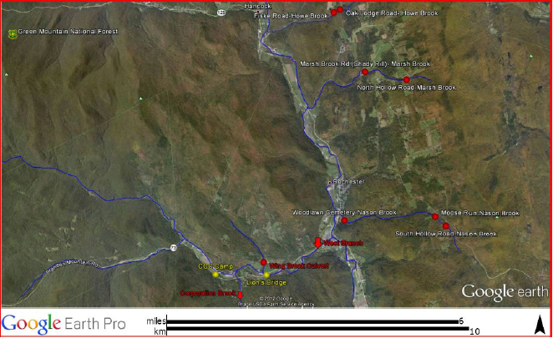

Appendix Map 1: Site location of the Upper White River (VT) Project. Subwatershed #500247 (West Branch), EBTJV priority score = 0.56 (medium rank category) and Subwatershed #500245 (Upper White River from Hancock Branch to Tweed River), EBTJV priority score = 0.48 (medium rank category); Site coordinates: CCC Camp on West Branch: 43.8495, -72.8583; Wing Brook, Wing Farm Road culvert: 43.8531, -72.8389; Lion’s Bridge on West Branch: 43.8495, -72.8381; Howe Brook, Fiske Road culvert: 43.9254, -72.8106; Howe Brook, Oak Lodge Road culvert: 43.9262, -72.8081; Marsh Brook, Shady Rill culvert: 43.9083, -72.7980; Marsh Brook, North Hollow Road culvert: 43.9059, -72.7817; Nason Brook, Woodlawn Cemetery culvert: 43.8652, -72.8063; Nason Brook, South Hollow Road culvert: 43.8636, -72.7662; Nason Brook, Moose Run culvert: 43.8665, -727702.

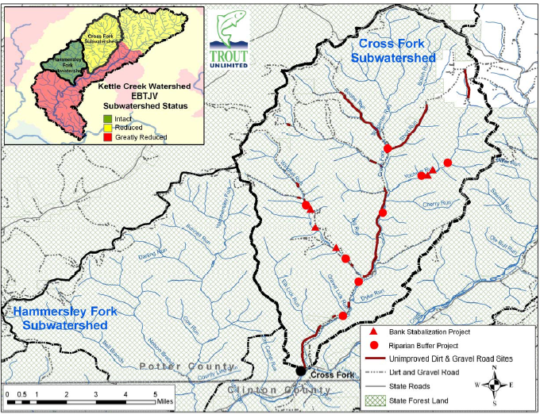

Appendix Map 2: Site location of the Cross Fork (PA) Project. Subwatershed #420247, EBTJV priority score = 1.35 (highest rank category); Site coordinates: -77° 49’ 12.29”, 41° 29’ 6.36” (mouth of the watershed).

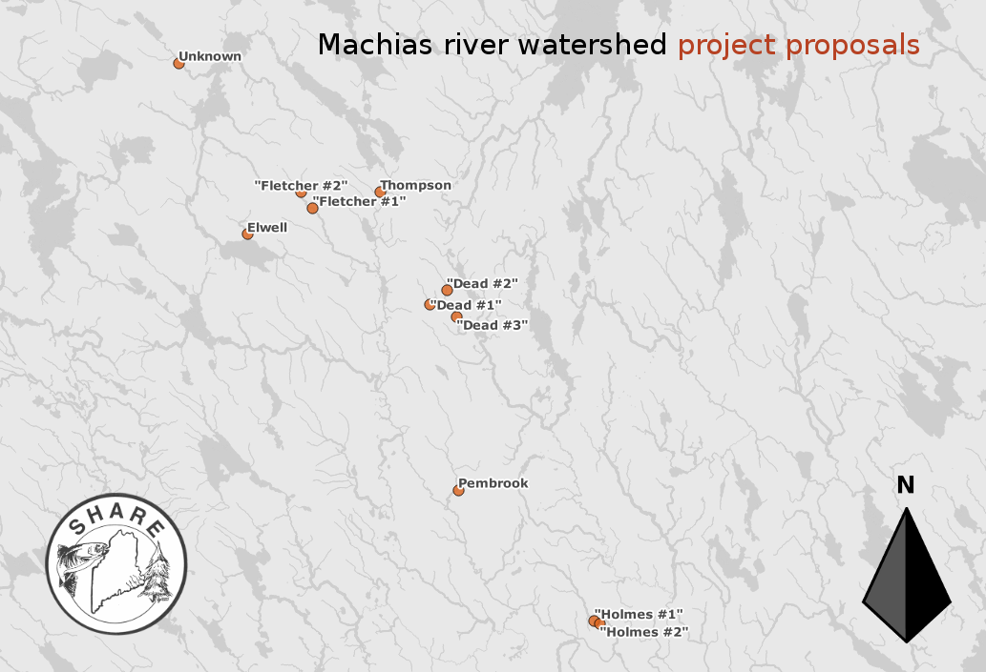

Appendix Map 3: Site location of the Machias River (ME) Project. Watershed #230545, EBTJV priority score = 1.58 (highest rank category), Subwatershed #230471, EBTJV priority score = 1.63 (highest rank category), Watershed #230477, EBTJV priority score = 1.63 (highest rank category), Watershed #230519, EBTJV priority score = 1.58 (highest rank category); Site coordinates:

Location of dam____ UTM X _ UTM Y
Pembrook 594279 4972332
Holmes 1 603208 4963706
Holmes 2 603569 4963543
Thompson 589145 4991940
Fletcher 1 584700 4990869
Fletcher 2 583946 4991901
Elwell 580415 4989152
Unknown 575911 5000417
Dead 1 592423 4984544
Dead 2 593505 4985460
Dead 3 594156 4983727

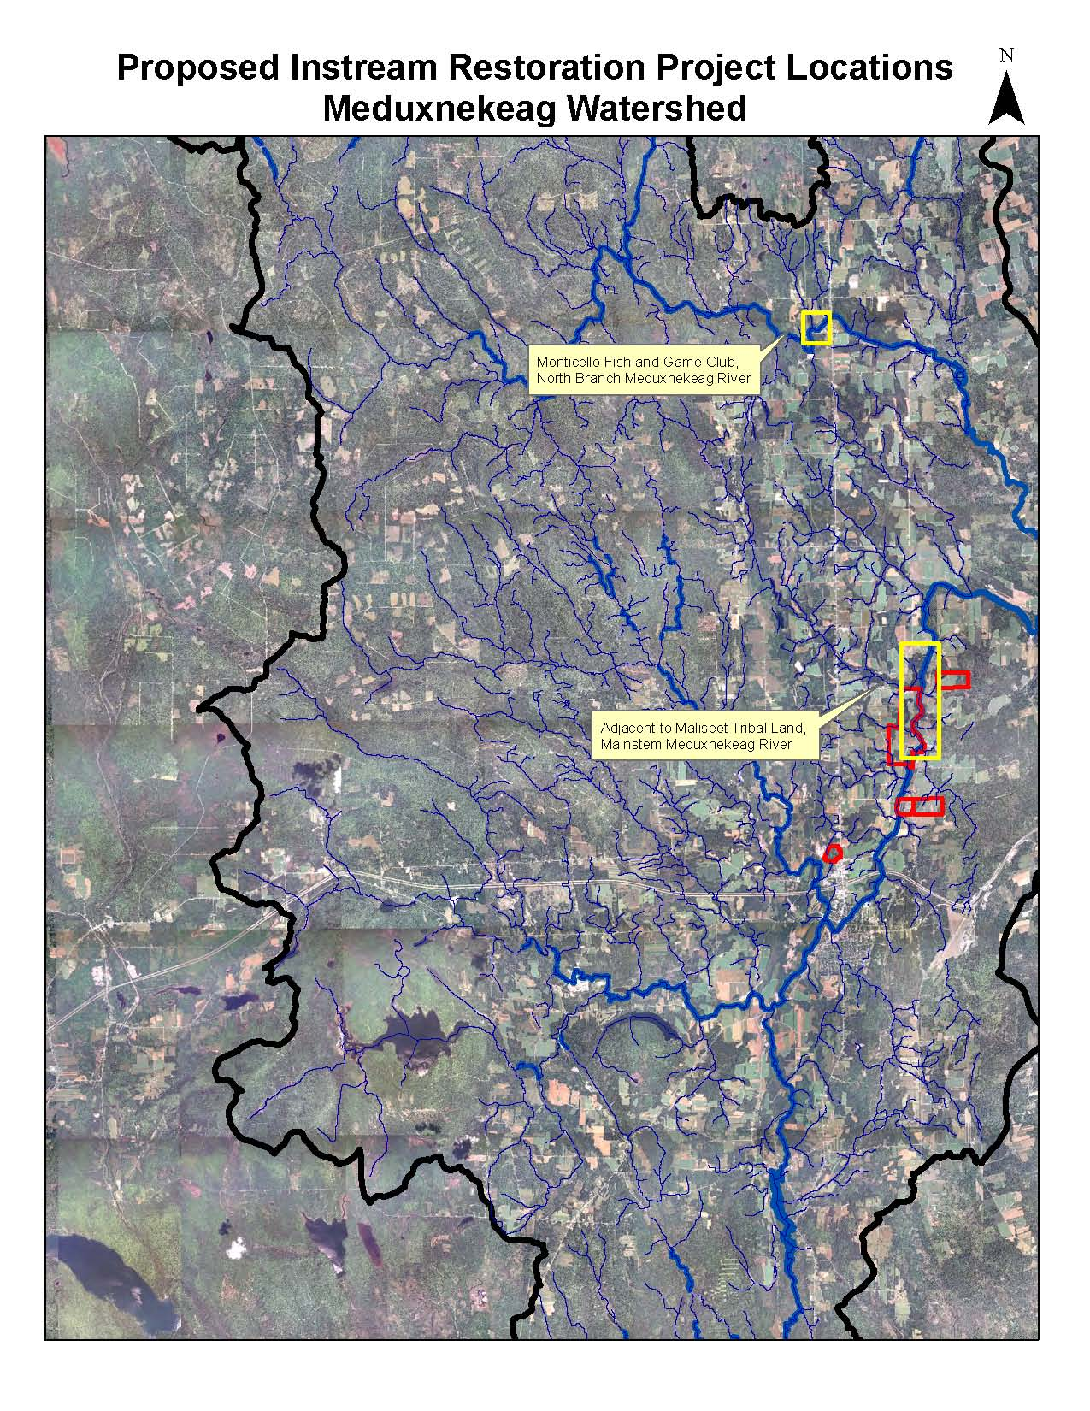
Appendix Map 4: Site location of the Meduxnekeag Watershed (ME) Project. Subwatershed #230172, EBTJV priority score = 1.56 (highest rank category; Site coordinates (in decimal degrees): (Site1) mainstem from Lowery Bridge @ 46.181106 N -67.804181 W to Covered Bridge @ 46.209678 N -67.800142 W and (Site 2) north branch at Monticello Fish and Game Club from 46.307786 N -67.846419 W to 46.309933 N -67.843678 W (NAD83, Zone 19N).

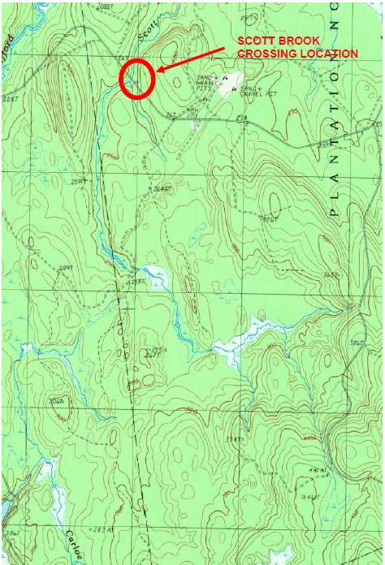

Appendix Map 5: Site location of the Scott Brook (ME) Project. Subwatershed #230427, EBTJV priority score = 1.36 (highest rank category); Site coordinates: Northing 604989, Easting 4995043.

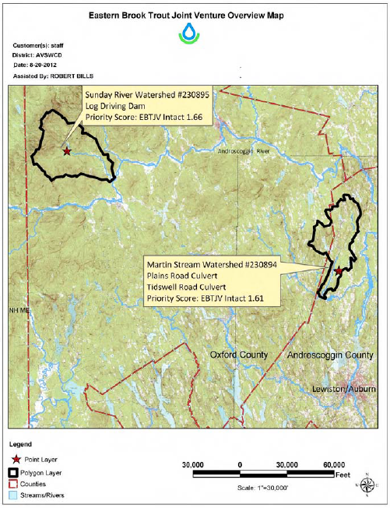

Appendix Map 6: Site location for Sunday River and Martin Stream (ME) Project. Martin Stream subwatershed # 230894, EBTJV priority Score =1.61 (highest priority ranking), Sunday River subwatershed #230895, EBTJV priority score =1.66 (highest priority ranking); Site coordinates:

Lively Brook Site 1: 400143.37E, 4906052.36N
Lively Brook Site 2: 399951.18E, 4905946.03N
Sunday River Site 0347260E, 4929331N

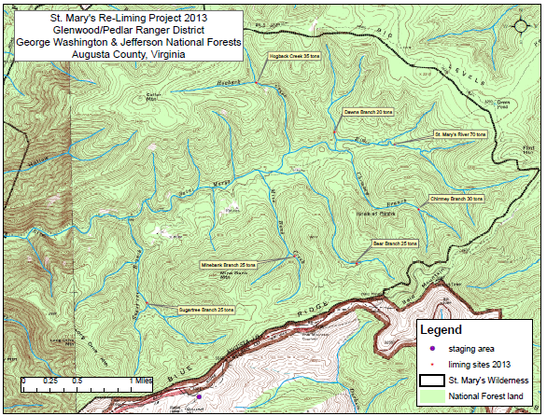
Appendix Map 7: Site location of the St. Mary’s River (VA) Project. Subwatershed #510428, EBTJV priority score = 0.46 (medium rank category); Site coordinates:

Sugartree Branch Lat/Long N 37 55' 8.6", W 79 06' 50.1"
Mine Bank Creek Lat/Long N 37 55' 16.1", W 79 05' 14.0"
Bear Branch Lat/Long N 37 55' 11.4", W 79 04' 36.7"
Chimney Branch Lat/Long N 37 55' 36", W 79 03' 56.3"
Hogback Creek Lat/Long N 37 56' 40.0", W 79 05' 35.4"
Dawn's Branch Lat/Long N 37 56' 14.2", W 79 04' 47.1"
Upper St. Mary's River Lat/Long N 37 56' 8.9", W 79 04' 11.6"

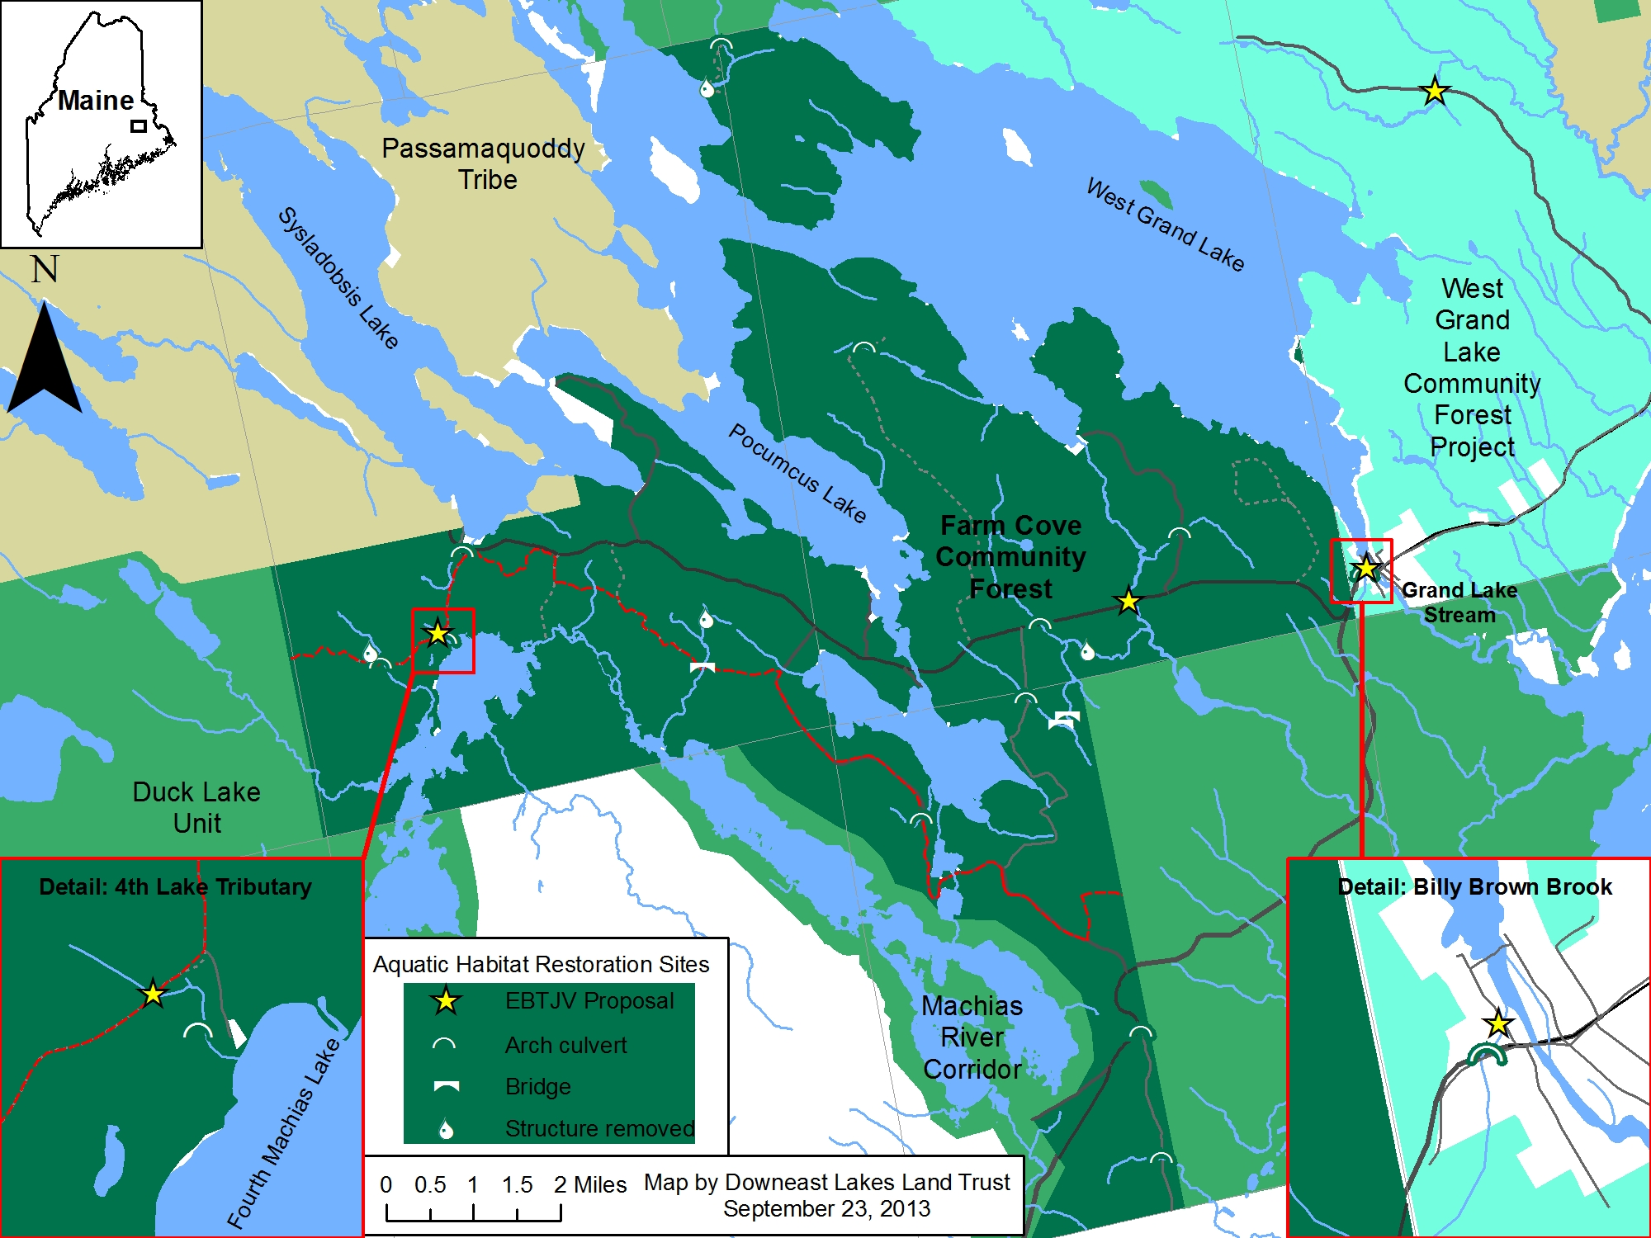
Appendix Map 8: Site locations of the Machias & Saint Croix River (ME) Project.
Sites: West Branch Amazon Brook; subwatershed #230400; EBTJV priority score = 1.63 (highest rank category). Grand Lake Brook; subwatershed #230458; EBTJV priority score = 1.61 (highest rank category). Billy Brown Brook; subwatershed #230425; EBTJV priority score = 1.36 (highest rank category). 4th Machias Lake tributary; subwatershed #230477; EBTJV priority score = 1.63 (highest rank category). Site coordinates:
Site | Lat | Long
West Branch Amazon Brook | 45.2586 | -67.7600
Grand Lake Brook | 45.1746 | -67.8337
Billy Brown Brook | 45.1795 | -67.7778
4th Machias Lake Trib | 45.1709 | -67.9961

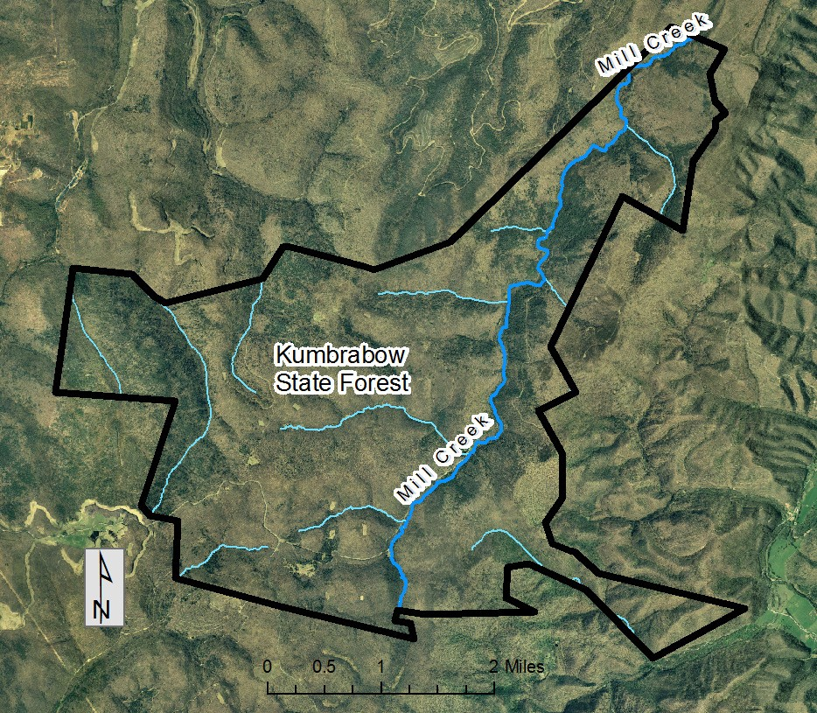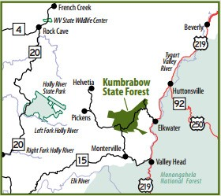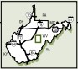

Appendix Map 9: Site location of Mill Creek (WV) Project. Subwatershed #540367; EBTJV priority score = 1.00 (high rank category); Site coordinates: 578792E, 4274272N to 582842E, 4282124N.

Appendix Map 10: Site location for Nash Stream Restoration & Columbia Road Culverts, Odell, Coos County, NH. Subwatershed #33096; EBTJV priority score = 1.00 (high rank category); Site coordinates: Upper Columbia Road-Nash Stream Crossing Decimal degree longitude: (NAD-1983) 44.7706, Decimal degree latitude: (NAD-1983) -71.4253. Lower Columbia Road-Nash Stream Crossing Decimal degree longitude: (NAD-1983) 44.7669, Decimal degree latitude: (NAD-1983) -71.4236. Nash Stream Mainstem Decimal degree longitude (NAD-1983) Upstream 44.6787, Decimal degree latitude: (NAD-1983) Upstream -71.4498, Decimal degree longitude: (NAD-1983) Downstream 44.6481, Decimal degree latitude: (NAD-1983) Downstream -71.4654.

Appendix Map 11: The Upper Shavers Fork Instream and Riparian Habitat Restoration, Randolph County, WV project site location map is currently unavailable. Subwatershed #540417; EBTJV priority score = 0.34 (low rank category); Site coordinates: 591010.39E, 4257010.23N.

