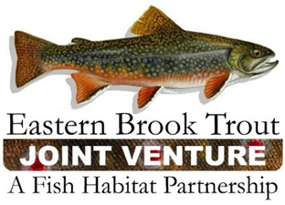
EBTJV Steering Committee Teleconference Summary
September 19, 2017

Attendees: Nat Gillespie, Dianne Timmins, Steve Hurley, Merry Gallagher, Matt Sell, Neal Hagstrom, Jake Rash, and Steve Perry.

The meeting was called to order by Chair Nat Gillespie at 1:00 p.m. on September 19th. The first order of business was for the Chair to establish a quorum, which was not achieved as only 7 Steering Committee members participated in the conference call.

The following notes summarize the business conducted during the teleconference on September 19, 2017:

- Since there was not a quorum of Steering Committee members (need at least 10) approval of the June 20, 2017 Steering Committee Call Summary was going to be completed via email.

- The EBTJV Coordinator provided an update on the EBTJV’s FY18 FWS-NFHAP Funding RFP.

- The EBTJV Coordinator provided an overview on the status of the 2017 Multistate Conservation Program funds for the Whitewater to Bluewater Project. The EBTJV executed its portion of the contract in early September, which is focused on working with ACFHP and SARP to finalize a tiered list of priority fish habitat connectivity focus areas that span the geographic boundaries of all three FHPs.

- A discussion occurred regarding planning the EBTJV’s next meeting. It was determined that the timing of the meeting would be delayed until after March 21, 2018 as that is when travel assistance funding would become available. A number of venues were suggested.

- The EBTJV Coordinator provided a brief summary of the Central Appalachia Habitat Stewardship Program.

- The EBTJV Coordinator highlighted agenda items that would be discussed at the October 2017 National Fish Habitat Board Meeting.

The EBTJV Steering Committee teleconference adjourned at ~2:30 p.m.

