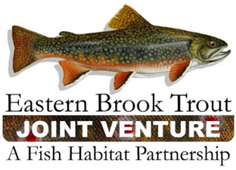
Steering Committee Conference Call
September 19, 2017
1:00 – 2:30 p.m.

Call-In Number: 888-844-9904
Participant Code: 7299722

AGENDA

- Steering Committee Roll Call & Establishment of Quorum (Nat Gillespie)

- Approval of June 20, 2017 Steering Committee Call Summary (Nat Gillespie)

- FY18 FWS-NFHAP Funding RFP Update (Steve Perry)

- 2017 Multistate Conservation Program – W2B (Steve Perry)

- EBTJV Meeting Discussion

- Central Appalachia Habitat Stewardship Program (Steve Perry)

- NFH Board Meeting – October 18-19, 2017 (Steve Perry)

- Other Business

