Eastern Brook Trout Joint Venture
A Fish Habitat Partnership
www.easternbrooktrout.org

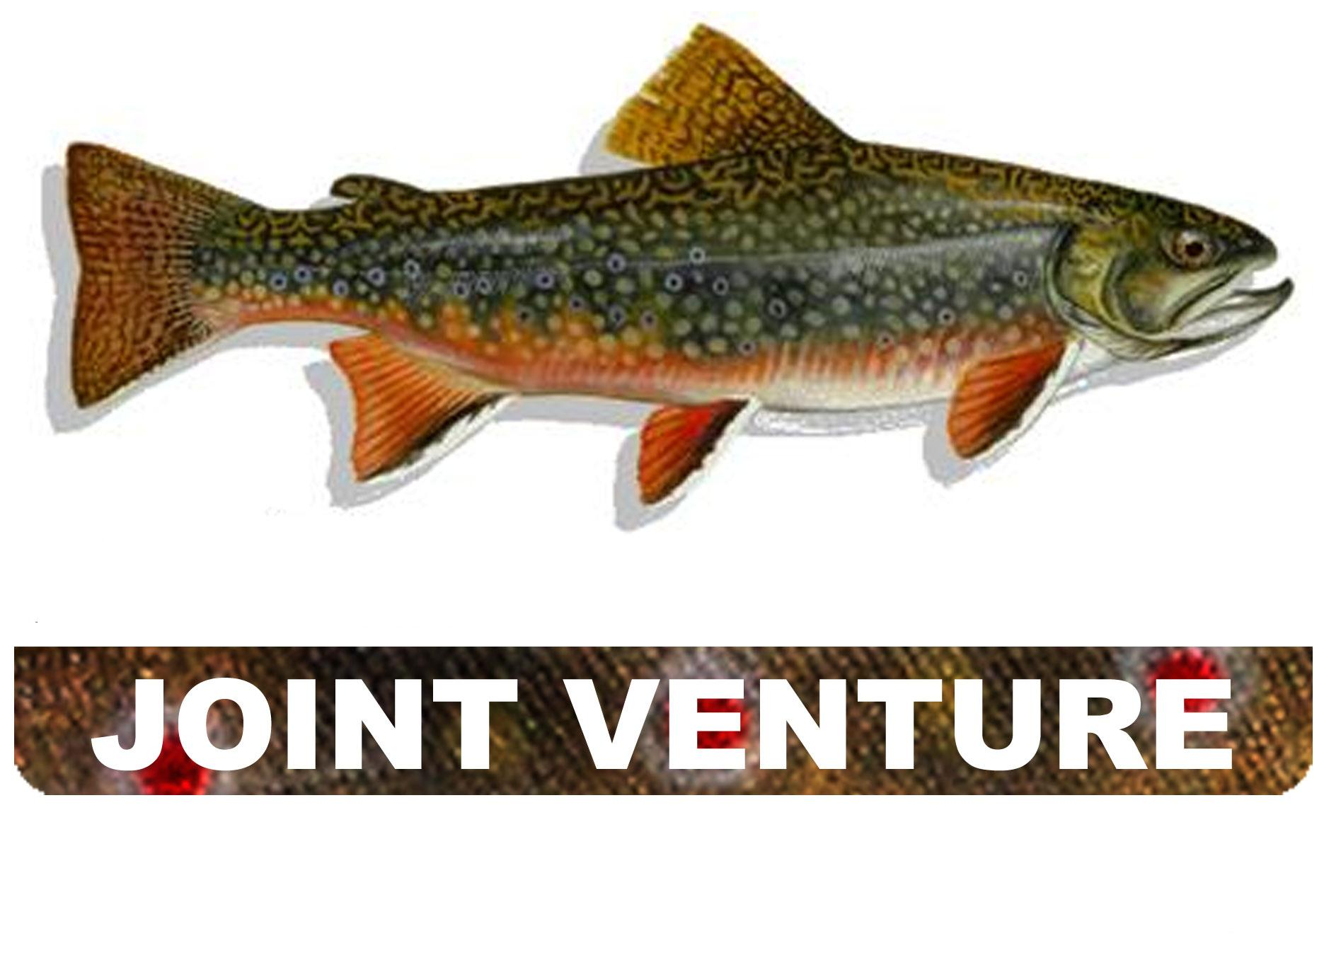
Eastern Brook Trout

A Fish Habitat Partnership

EBTJV Partnership Meeting
Kettle Pond Visitor Center
Rhode Island National Wildlife Refuge Complex
Agenda

Tuesday January 8, 2019

9:00 a.m. Welcome and Introductions (Nat Gillespie)

9:15 a.m. Sense of Place: Short regional presentations on Brook Trout management/projects/challenges
- RI (Cory Pelletier)
- MA (Steve Hurley)
- CT (Neal Hagstrom/Mike Beauchesne/Brian)

10:00 a.m. Update on Nb findings, recent range-wide genetic analysis results, and future possibilities for making an updateable web viewer that combines genetic analyses and patches (Jason Coombs)

10:30 a.m. Break

10:45 a.m. Obstacles to Brook Trout population restoration (Group discussion)

11:15 a.m. Genetics – how can we best use this growing body of information (Group discussion)

12:00 p.m. Lunch (on your own)

1:30 p.m. Resiliency – the ways to provide resiliency to Brook Trout populations (Group discussion)
- Trends in past 12 years
- EBTJV annual funding – criteria and guidance

2:30 p.m. Re-Introduction of wild Brook Trout – what needs to be considered (Group discussion)
- Success stories
- Factors that need to be considered
- Opportunities

3:30 p.m. Break

3:45 p.m. Recreational use – increased recreation on public lands and its growing impacts (Group discussion)
- Trends in past 12 years and their impacts
- What needs to be addressed?

4:45 p.m. Summary of group discussions (Nat Gillespie)

5:00 p.m. Adjourn

Wednesday January 9, 2019

9:00 a.m. Moving the needle – tracking the progress being made to conserve Brook Trout (Group discussion)
- How are states tracking projects and determining progress?
- Citizen Science – examples and opportunities
- Agency long-term data sets and research stations (USGS, USFS, States)

9:45 a.m. Best management practices – what do private landowners need know (Group discussion)

10:30 a.m. Break

10:45 a.m. Implementing the Roadmap to Brook Trout Conservation and future funding (Group discussion)

11:30 a.m. Meeting wrap-up and next steps for EBTJV (Nat Gillespie)

12:00 p.m. Adjourn

1:00 p.m. Optional field trip to local Brook Trout site (weather permitting)

EBTJV Meeting Dates:

January 8 (9:00 a.m. – 5:00 p.m.) and January 9 (9:00 a.m. – 12:00 p.m.), 2019

EBTJV Meeting Location:

Rhode Island National Wildlife Refuge Complex
Kettle Pond Visitor Center
50 Bend Road
Charlestown, RI 02813

Recommended Lodging:

Hampton Inn in South Kingstown, RI – 15 miles from meeting location
20 Hotel Drive
South Kingstown, RI 02879

Dinner Option:

The Coast Guard House Restaurant
40 Ocean Road
Narragansett, RI 02882

Driving Directions:

From recommended lodging to meeting location (14.8 miles)

- Start out going east on Hotel Dr toward Commerce Dr. - 0.01 miles
- Take the 1st left onto Village Square Dr. - 0.16 miles
- Turn right onto S County Commons Way - 0.07 miles
- Turn right onto Tower Hill Rd/US-1 S. Continue to follow US-1 S. - 11.75 miles
- Keep right at the fork to go on Post Rd/US-1 S/RI-2 - 2.62 miles
- Turn slight right onto Bend Rd - 0.24 miles

From meeting location to recommended lodging

- Start out going east toward Bend Rd - 0.03 miles
- Turn right onto Bend Rd - 0.24 miles
- Turn slight right onto Post Rd - 0.11 miles
- Turn left onto Wildflower Rd - 0.02 miles
- Turn left onto Post Rd/US-1 N/RI-2 - 3.13 miles
- Keep right at the fork to go on US-1 N - 11.39 miles
- Turn left onto S County Commons Way - 0.17 miles
- Turn left onto Village Square Dr - 0.16 miles
- Turn right onto Hotel Dr



