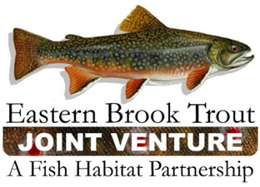
EBTJV Steering Committee Teleconference Summary
March 20, 2018

Attendees: Nat Gillespie, Dianne Timmins, Fred Hensen, Merry Gallagher, Matt Sell, Allan Heft, Callie McMunigal, Matt Kulp, John Magee, Jake Rash, Corey Pelletier, and Steve Perry.

The meeting was called to order by Chair Nat Gillespie at 1:00 p.m. on March 20th. The first order of business was for the Chair to establish a quorum, which was achieved as 11 Steering Committee members participated in the conference call.

The following notes summarize the business conducted during the teleconference on March 20, 2018:

- Steering Committee members approved the December 19, 2017 SC Call Summary.

- The Steering Committee was provided an overview of the EBTJV Sponsored Symposium, Eastern Brook Trout Management: Can Brook Trout Hold On or Expand into the Future?, which is being held at the 2018 AFS Annual Meeting in Atlantic City, NJ.

- Continued support and maintenance of the EBTJV website was discussed and a resolution to these issues is being pursued.

- Updating the EBTJV Catchment Assessment Database was discussed and it was decided the States with data updates would schedule a conference call with Jason Coombs to talk about their needs and next steps.

- An update on FY18 EBTJV/FWS-NFHAP Projects was provided, which centered on the Project Lead for the Dam Removal Project on the Childs River communicating they are withdrawing their application because they anticipate a delay in initiating/completing the project work.

- Other business discussed was the EBTJV entering into an agreement with RepYourWaters that would result in 1.5% of the sales of certain types of apparel being donated to the EBTJV’s non-profit account housed within the National Fish Habitat Fund (aka Beyond the Pond).

The EBTJV Steering Committee teleconference adjourned at 2:30 p.m.

