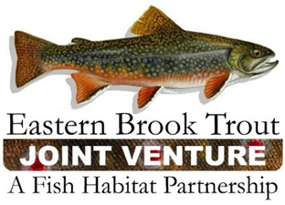
EBTJV Steering Committee Teleconference Summary
December 18, 2018

Participants: Nat Gillespie, Dianne Timmins, Fred Henson, Merry Gallagher, Steve Reeser, Adam Kautza, Lee Simard, Mike Beauchene, Steve Faulkner, Matt Kulp, Geof Day, John Magee, Jake Rash, and Steve Perry.

The meeting was called to order by Chair Nat Gillespie at 1:00 p.m. on December 18th. The first order of business was for the Chair to establish a quorum, which was achieved as twelve Steering Committee members participated in the conference call.

The following notes summarize the business conducted during the teleconference on December 18, 2018:

- The Steering Committee approved the September 18, 2018 Conference Call Summary.

- The Steering Committee approved to have Nat Gillespie serve as Chair and Steve Reeser as Vice-Chair for 2 additional years.

- The Steering Committee approved On-The-Ground-Project Rankings for FY19 FWS-NFHAP Funding Considerations.

- The Steering Committee approved the EBTJV Coordination and Operations Project for FY19 FWS-NFHAP Funding.

- The Steering Committee reviewed a draft of the EBTJV Roadmap to Brook Trout Conservation. An Outreach Working Group was established and charged with developing talking points and targeted messages as part of rolling out this new document. Members of this working group include Dianne Timmins, Steve Faulkner, Nat Gillespie, Jake Rash, and Steve Perry.

The EBTJV Steering Committee teleconference adjourned at 2:15 p.m.

