Eastern Brook Trout Joint Venture
A Fish Habitat Partnership
www.easternbrooktrout.org

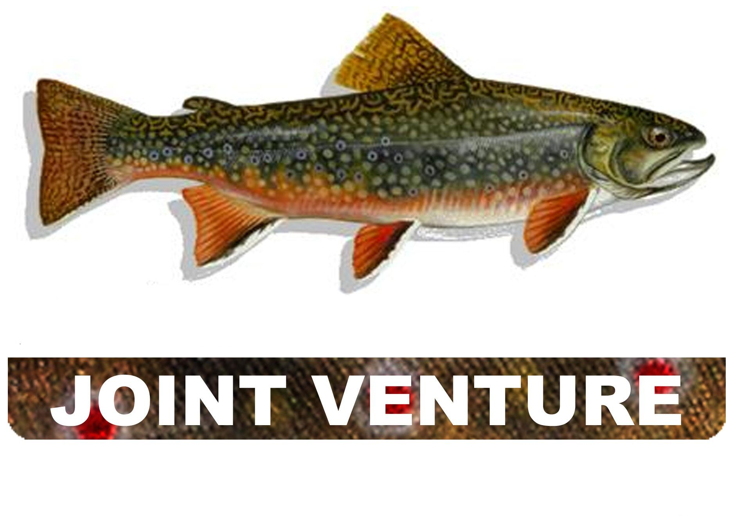
Eastern Brook Trout

A Fish Habitat Partnership

EBTJV Partnership Meeting
January 8-9, 2019
South Kingstown, RI

Meeting Summary

Twenty-six individuals attended the EBTJV Meeting on January 8th and 20 on January 9th (Appendix Table I).

January 8, 2019 (0900 hrs-1700 hrs)

After meeting participants introduced themselves representatives from RI, MA, and CT state fisheries agencies provided short presentations highlighting Brook Trout management issues being addressed respectively. One of the principle challenges that RI is faced with is the headwaters of many of their streams containing wild Brook Trout have high water temperatures due to the presence of dams impounding waters. These impoundments are relatively small, shallow ponds that get excessively warm during the summer months and this warm water spills over the dams and negatively impacts the streams for several miles downstream. The wild Brook Trout in these streams are typically found in the middle reaches, where stream side shading and groundwater influences the cooling of the water temperatures to levels suitable for Brook Trout. While the Rhode Island Department of Environmental Management (RIDEM) is interested in removing the dams creating these headwater impoundments, there is cultural and social related resistance to removing these dams. The MA presentation was centered on the extensive amount of wild Brook Trout research and conservation work that has occurred in the southeastern region of the State. While Brook Trout are still common in many portions of MA streams, particularly in the Berkshires, they are greatly depleted in the eastern portion of the State. The large number of dams (2,645+) in MA disrupts aquatic connectivity. The focus of wild Brook Trout management in southeastern MA has been diverse, including land protection, habitat improvement, population monitoring, discontinuing the stocking of Brown Trout in wild Brook Trout streams, monitoring stream temperatures, PIT tagging studies and dam removals. Brook Trout response to warming waters in coastal streams is limited because cold water refugia is lacking. An overview of the conservation actions implemented on a number of MA coastal streams containing wild sea run Brook Trout was also provided. CT has been installing culvert baffle systems and Outlet Cast-in-Place Pool/Weir Fishways as a way to address fish passage barriers where costs of replacing culverts is too expensive and/or difficult to do. CT is also using the EBTJV catchment data to actively track the status of wild Brook Trout in the State.

Jason Coombs (UMass) provided an update on catchment assessment news, patch-related effective breeding population (N_{b}) findings, recent range-wide genetic analysis results, and future possibilities for making an updateable web viewer that combines genetic analyses and patches. The current EBTJV wild Brook Trout status assessment uses the NHD Plus Version 2 to delineate catchments, however NHD Plus High Resolution is being built that uses data at 1:24,000 or better, which will result in finer catchment delineation. For example, NHD+ V2 delineates 25 catchments in a HUC12 whereas NHD+ HR delineates 156 catchments in the same HUC12. The NHD+ HR is nearing completion nationally. The only portion of the EBTJV geographic area that has not be completed yet is around the Great Lakes, the northern portions of VT and western ME. NHD+ HR can be inserted into the current algorithm develop for the EBTJV catchment assessment. However, the change would result in States having to re verify their respective catchment classifications, though the higher resolution for delineating catchments should lessen the magnitude of this task. Further research on using N_{b} for Brook Trout population monitoring is not as promising as first thought. It appears that N_{b} does not change much within streams among years. However, it still may be a useful approach for evaluating impacts of management actions (↑carrying capacity ≈ ↑ N_{b}) and coupled with predictive model (nearly completed), it could enable comparison of measured wild Brook Trout population status with expected. The range-wide Brook Trout genetic analysis entailed sampling 836 wild populations, including ~22,000 individuals. Eighteen hatchery strains were identified from Maine to Tennessee. The outputs from this analysis include determining the level of hatchery introgression. The analysis also resulted in assigning 94.6% of the individuals to their correct EBTJV patch. It was indicted that the development of a patch and genetics viewer (currently being built) would provide value because the genetic data allows depicting hatchery introgression, within patch genetic differentiation, genetic diversity metrics (allelic richness, heterozygosity), and N_{b} and N_{e}. Jason completed his presentation by identifying the following for the groups’ considerations:

- NHD+ HR: Increased accuracy vs. inability to initially accurately track catchment classification change (i.e. change in area measurements)

- Standardized genetic panel: increased efficiency (SNPs) vs. legacy datasets (microsats)

- Updateable web app: Ability to self-maintain catchments (states) vs. non-tractable time-stamp of range-wide layer (EBJTV) and feasibility of automating patch layer & genetic assignment analyses after updates.

The meeting attendees spent the rest of Day 1 discussing these three topics and came to consensus that the next steps for the EBTJV with regards to the topics are:

- Initiate a process that results in allowing the catchment database to be updated by the States;

- Organize a genetics workshop for EBTJV partners;

- Initiate a process to convert the catchment delineation layer from HD+ V2 to HD+ HR when development of the new catchment layer was complete.

January 9, 2019 (0900 hrs-1200 hrs)

During Day 2 of the meeting, group discussions centered on the following two questions:

- What do you see as the biggest obstacles to wild Brook Trout conservation?
- What is being done to track progress being made to conserve wild Brook Trout?

Obstacles identified included dealing with user groups whose interest doesn’t encompass taking actions for the purpose of conserving wild Brook Trout (e.g. people who don’t want dams removed because they enjoy the benefits/values impounded waters provide); interest in fishing for species that may negatively impact wild Brook Trout populations (e.g. Brown Trout, Rainbow Trout, and Smallmouth Bass); communicating the value of wild Brook Trout conservation in the face of success stories; recent disease issues (i.e. whirling disease and gill lice); identifying high priority wild Brook Trout projects given the considerations that are required for project size and cost; protecting the current status of wild Brook Trout populations, in essence keeping the “good good”; commercial forest management practices; and, climate change. To help overcome some of these obstacles, it was recommended the EBTJV complete an assessment of the strengths and weaknesses of the many Brook Trout-related decision support tools and hold a workshop that provides users with a better understanding of how and when to use these tools.

The discussions of tracking progress being made to conserve wild Brook Trout resulted in a consensus in developing a standard spreadsheet that would be sent to one contact for each of the EBTJV formal partners that would ask for a number of metrics for each conservation project that was completed during a calendar year. Metrics could include things like project name, general project location, project intent, project outputs/outcomes, and total costs.

At the conclusion of the meeting at noon, Corey Pelletier (RIDEM) took a number of meeting attendees on site visits to several local wild Brook Trout locations.

Appendix Table I. Listing of EBTJV Meeting Attendees

