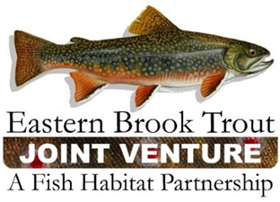
EBTJV Steering Committee Meeting Summary
June 12, 2019

Participants: Nat Gillespie, Dianne Timmins, Jim Habera, Alan Heft, Steve Reeser, Dan Rankin, Jason Detar, Lee Simard, David Thorne, Callie McMunigal, Steve Faulkner, Matt Kulp, Jake Rash, Matt Sell, Eric MacMillian, David Kazyak, and Steve Perry.

This in-person meeting held in Frostburg, MD was called to order by Chair Nat Gillespie at ~1:30 p.m. on June 12th. The first order of business was for the Chair to establish a quorum, which was achieved as thirteen Steering Committee members participated in the meeting.

The following notes summarize the business conducted during the meeting on June 12, 2019:

- The Steering Committee approved the March 26, 2019 Steering Committee Call Summary.

- Steve Perry presented a brief update on the EBTJV’s FY19 NFHAP Workplan and Accomplishment Report, indicating this document was submitted to the US Fish and Wildlife Service for their review and actions on May 8, 2019. It’s unknown at this point when the Service is expected to issue its final decision on FY 19 NFHAP funding allocations to Fish Habitat Partnerships.

- The Steering Committee discussed Keith Nislow and Jason Coomb’s proposal to make the EBTJV Assessment Database update-able by EBTJV partners. During the discussions of the proposal a keen interest was expressed for developing a new data layer that would depict trout population abundance for those catchments where this data is available. There was support expressed for expanding the proposal’s scope of work to include developing a trout population abundance data layer.

The EBTJV Steering Committee meeting adjourned at ~4:30 p.m.

