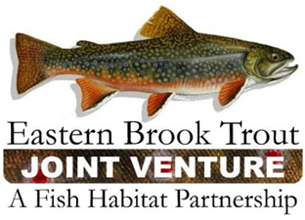
EBTJV Steering Committee Teleconference Summary
March 26, 2019

Participants: Nat Gillespie, Dianne Timmins, Fred Henson, Merry Gallagher, Alan Heft, Matt Sell, Adam Kautza, Lee Simard, Mike Beauchene, David Thorne, Callie McMunigal, Steve Faulkner, Matt Kulp, Shawn Rummel, John Magee, Jake Rash, and Steve Perry.

The meeting was called to order by Chair Nat Gillespie at 1:00 p.m. on March 26th. The first order of business was for the Chair to establish a quorum, which was achieved as fifteen Steering Committee members participated in the conference call.

The following notes summarize the business conducted during the teleconference on March 26, 2019:

- The Steering Committee approved the December 18, 2018 Steering Committee Call Summary.

- The Steering Committee reviewed the EBTJV responses to its FY19 NFHAP Workplan and Accomplishment Report, which will be submitted to the US Fish and Wildlife Service for their review at the appropriate time. Based on a self-assessed level 3 score for each of the 8 evaluation criteria, the EBTJV could be allocated the maximum level 3 funding amount, as it has been the previous two funding allocation cycles (FY17 and FY18).

- The Steering Committee was provided an update on outreach activities related to the EBTJV’s Eastern Brook Trout Roadmap to Conservation. To date, the Roadmap has been distributed to EBTJV members, placed on the EBTJV’s web portal, publicized in a newsletter produced by National Fish Habitat Partnership, and the National Fish Habitat Board received a briefing on it during their March meeting in DC.

- The Steering Committee reviewed a summary of the outcomes from its partnership meeting held in South Kingstown, RI during early January, 2019. The three principal outcomes were to develop a process that results in allowing the catchment database to be updated by the States, organize a genetics workshop, and convert the catchment delineation layer from HD+ V2 to HD+ HR when development of the new catchment layer is complete.

- The Steering Committee was provided an overview of the East Coast Trout Management and Culture Workshop VI.

- Topics under Other Business consisted of the EBTJV’s web portal support contract, 2019 AFS Symposium, and fish passage.

The EBTJV Steering Committee teleconference adjourned at 3:00 p.m.

