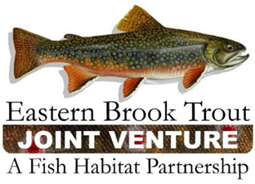
Steering Committee Teleconference
September 17, 2019
1:00 – 3:00 p.m.

Call-In Number: 866-793-8933
Participant Code: 86086865

AGENDA

- Steering Committee Roll Call & Establishment of Quorum (Nat Gillespie)

- Approval of June 12, 2019 Steering Committee Meeting Summary (Nat Gillespie)

- Update on the FY19 FWS-NFHAP Funding Allocation for EBTJV Projects (Steve Perry)

- Development of the FY20 EBTJV Coordination and Operations Project Proposal (Steve Perry)

  - EBTJV Coordinator - Original Scope of Work
  - EBTJV Coordinator - FY19 Scope of Work

- Discussions about the EBTJV Assessment Database

- EBTJV Science and Data Committee Members

- Discussions about the Brook Trout Genetics-Related Management Questions

- Discussions about Developing Fund Raising and Marketing Strategies for 2020 relative to Distribution Plan of RoadMap 2: All members of EBTJV, National Fish & Wildlife Foundation, Hewlett Foundation, potential corporate partners, others

- Other Business

  - Website Update

