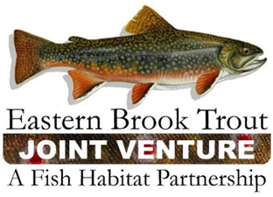
Steering Committee Teleconference
March 17, 2020
1:00 – 3:00 p.m.

Call-In Number: 866-793-8933
Participant Code: 86086865

AGENDA

- Steering Committee Roll Call & Establishment of Quorum (Nat Gillespie)

- Approval of December 17, 2019 Steering Committee Meeting Summary (Nat Gillespie)

- Scope of Work for the EBTJV Catchment Web Updater Project (Steve Faulkner/Jake Rash/Jason Detar/Callie McMunigal)

- Genetics Workshop Proposal (Steve Faulkner)

- Approval of the FY20 EBTJV Coordination and Operations Project (Steve Perry)

- EBTJV Website Changes (Steve Perry)
- Home page
- About/Groups/Steering Committee
- Projects
- Resources

- Approval of 2020 EBTJV Website Maintenance Contract (Steve Perry)

- Eastern Native Brook Trout Poster Funding Request (Steve Perry)

- Altoona Curve Brookie Weekend June 19-21, 2019 (Steve Perry)

- Other Business

- There is a need for the Steering Committee to develop a recruitment and selection process for a new EBTJV Coordinator.

