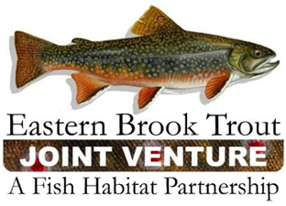
Steering Committee Teleconference
June 16, 2020
1:00 – 3:00 p.m.

Call-In Number: 866-793-8933
Participant Code: 86086865

AGENDA

- Steering Committee Roll Call & Establishment of Quorum (Nat Gillespie)

- Continued approval of December 17, 2019 Steering Committee Meeting Summary (Nat Gillespie) Note: Needs at least 1 more affirmative vote from a SC member that has not yet voted.

- Continued approval of 2020 EBTJV Website Maintenance Contract (Nat Gillespie) Note: Needs at least 1 more affirmative vote from a SC member that has not yet voted.

- Continued approval of Eastern Native Brook Trout Poster Funding Request (Nat Gillespie) Note: Needs at least 1 more affirmative vote from a SC member that has not yet voted.

- Approval of March 17, 2020 Steering Committee Meeting Summary (Nat Gillespie)

- NFWF Process for recruiting and selecting a new EBTJV Coordinator (Nat Gillespie/Steve Perry)

- Update on FY20 FWS-NFHAP Funding for Brook Trout Conservation Projects (Callie McMunigal/Steve Perry)

- Other Business

