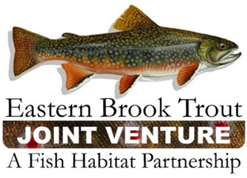
EBTJV Steering Committee Meeting Summary
September 15, 2020

Participants: Nat Gillespie, Dianne Timmins, Greg Kozlowski, Matt Sell, Jason Detar, Lee Simard, David Thorne, Callie McMunigal, Matt Kulp, John Magee, Jake Rash, and Steve Perry.

This teleconference was called to order by Chair Nat Gillespie at ~1:00 p.m. on September 15th. The first order of business was for the Chair to establish a quorum (≥10 SC members), which was achieved as eleven Steering Committee (SC) members participated in the meeting.

The following notes summarize the business conducted during the conference call held on September 15, 2020:

- The June 16, 2020 Steering Committee Meeting Summary was approved.

- The need for the SC to elect its Chair and Vice Chair in December 2020 was discussed. Nominees for these two leadership positions will be put forward during the next scheduled SC teleconference for their considerations and action.

- The EBTJV Coordinator Transition Committee provided its progress report.

- The 2nd draft of the Brook Trout poster being developed by TU was reviewed by the SC and several suggested edits were recommended.

- Other business discussed included a reminder that the due date for FY21 FWS-NFHAP Brook Trout Conservation Project Proposals is 5:00 p.m. on October 9, 2020; that all of the EBTJV's FY20 project agreements have been executed by the USFWS; and, progress of the Catchment Data Update Project.

The EBTJV Steering Committee meeting adjourned at 2:20 p.m.

