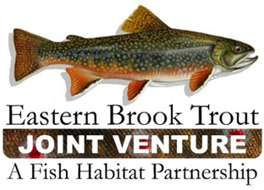
EBTJV Steering Committee Meeting Summary
March 16, 2021

Participants:
Present=X
Beauchene, Mike |  | Eltz, Brian | x | Habera, Jim |  | Maloney, Lori | x | Rash, Jake | x
Baker, Sarah |  | Erikson, Glenn | x | Kautza, Adam | x | McMunigal, Callie | x | Sell, Matt | x
Curley, Keith |  | Faulkner, Steve | x | Kozlowski, Greg | x | Palmer, Eric |  | Rummel, Shawn
Geoff Day |  | Fink, Brad | x | Kulp, Matt | x | Pelletier, Corey |  | Shramko, Ross | x
Detar, Jason | x | Gallagher, Merry |  | Rankin, Dan |  | Perry, Stephen | x | Simard, Lee | x
Reeser, Steve |  | Gillespie, Nat | x | Kratzer, Jud | x | Timmins, Dianne | x | Thorne, David
 |  | Goclowski, Matt |  |  |  | Goetz, Dan | x
 |  | Lawrence, Matt

This video conference meeting was called to order by Chair Nat Gillespie at ~1:00 p.m. on December 21st. The first order of business was for the Chair to establish a quorum (≥10 SC members), which was achieved as 18 Steering Committee (SC) members participated in the meeting.

The following notes summarize the business conducted during the meeting held on December 21, 2021:

- The Steering Committee voted to approve the summary of the Sept 21, 2021 Steering Committee Meeting

- The steering committee members gave detailed updates from their states and regions. Notes are included in a separate document. Major themes included state regulation changes, state trout management plans, changes in brook trout occupancy, gill lice, and research topics.
- Callie McMunigal (FWS) said how FWS is working on an AOP training for Forest Service stream sim, as a more accessible abbreviated workshop/stepping stone to a longer training. They are planning Train the Trainer events for three areas in range – stay tuned.

- Jud Kratzer is the new liaison to EBTJV from AFS.

- Chair Nat Gillespie discussed the Bipartisan Infrastructure Bill and USFS programs under it. Additionally, the SC discussed if and how EBTJV can help pair on the ground projects with funding under various programs.

The EBTJV Steering Committee meeting adjourned at 3:00 p.m.

Upcoming dates: EBTJV Annual meeting April 20-21 2022 National Conservation Training Center, Shepherdstown, WV.

Next SC meeting March 15, 2022 1-3pm Teams link

