
EBTJV Stats Jan-Dec 2022
Contents
Overview 2
Top Pages 3
Content Drilldown 4
Science Data Content Drilldown 5
Projects Content Drilldown 6
Groups Content Drilldown 7
Why Wild Brooke Trout Content Drilldown 8
Members Content Drilldown 9
Top States 10
Top New York Cities 11
Top Virginia Cities 11
Top Massachusetts Cities 11
Top Pennsylvania Cities 12
Top Georgia Cities 12
Top North Carolina Cities 12
Top Referral Traffic 12

Overview
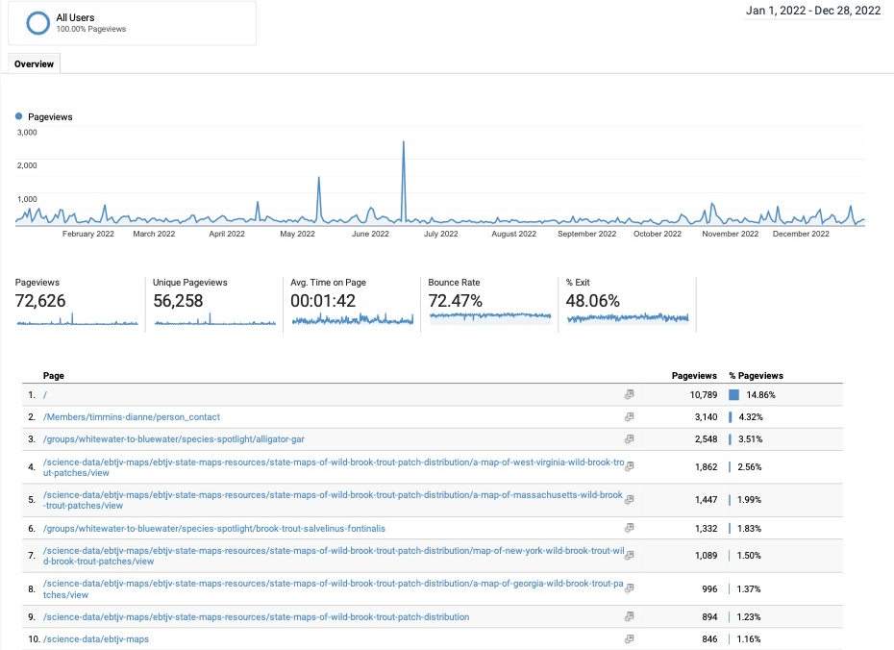

Top Pages
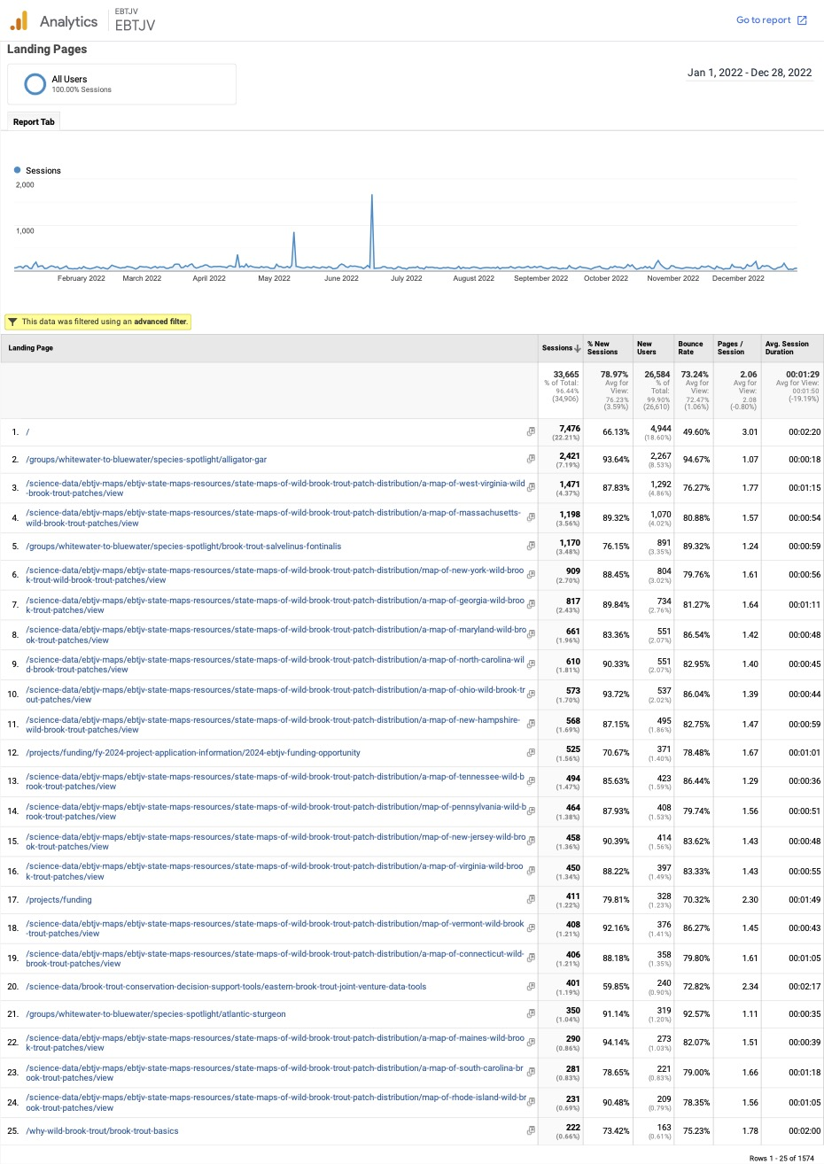

Content Drilldown
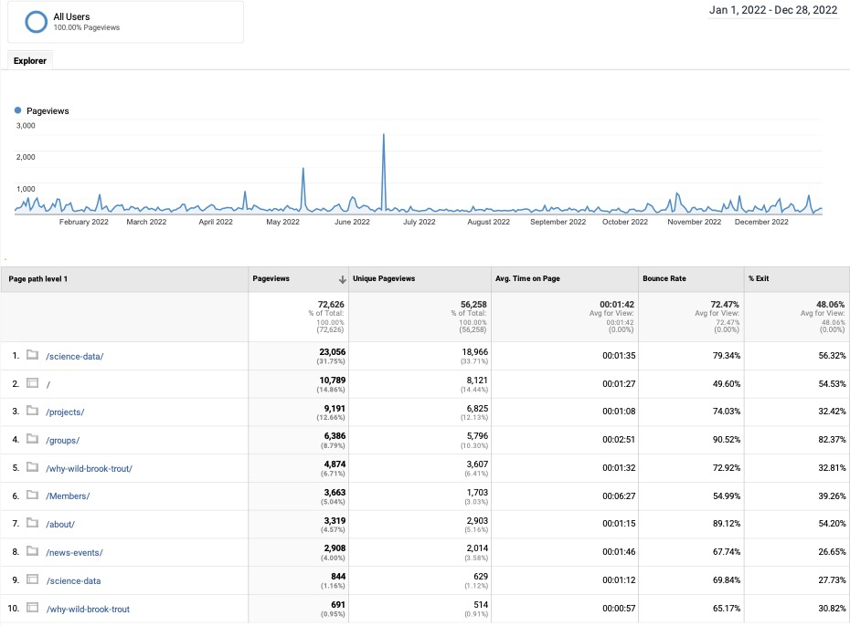

Science Data Content Drilldown
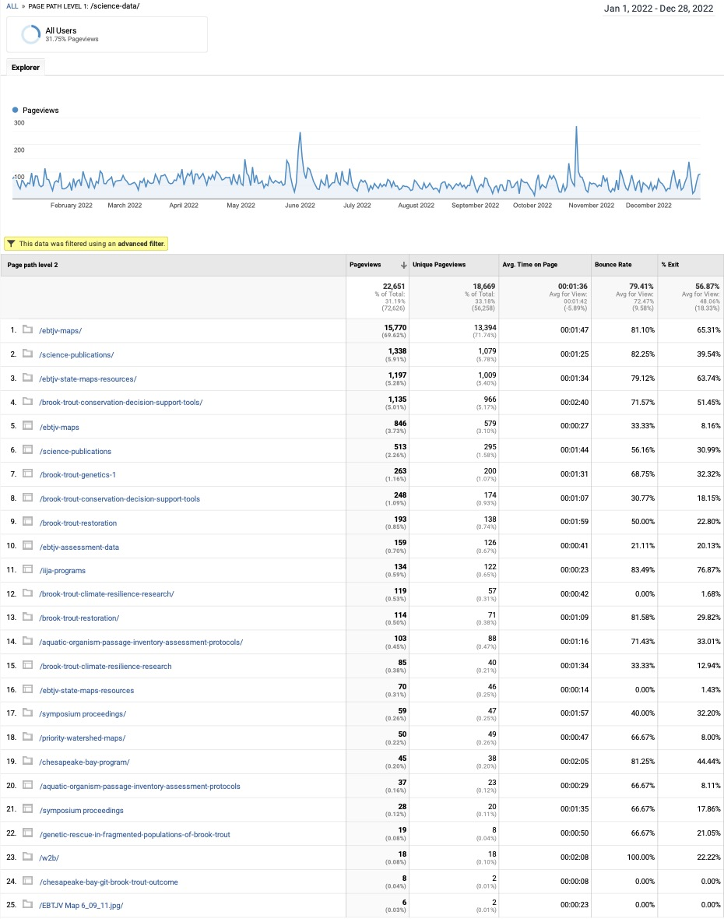

Projects Content Drilldown
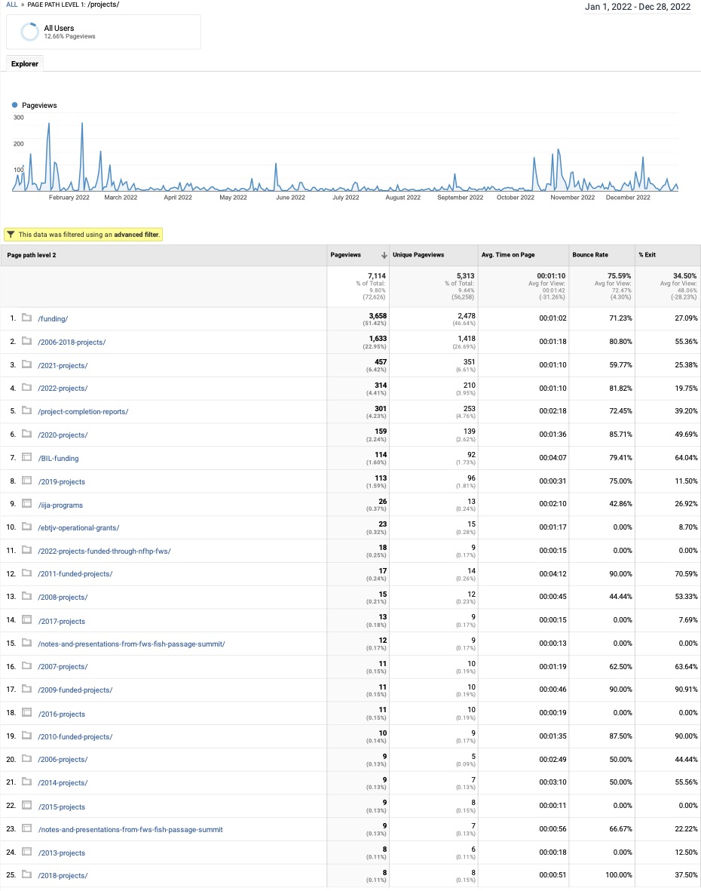
Groups Content Drilldown
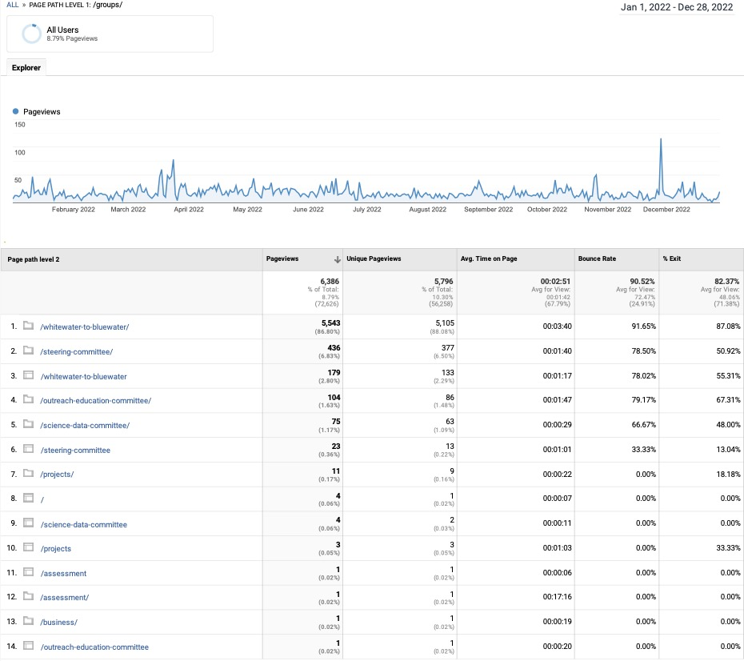
Why Wild Brooke Trout Content Drilldown
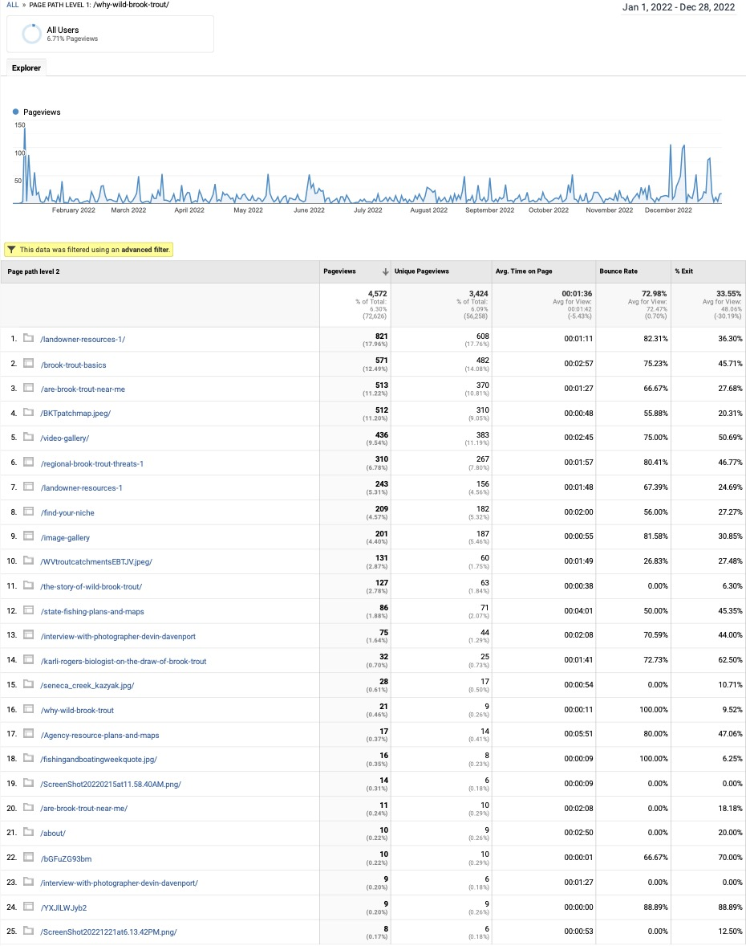

Members Content Drilldown
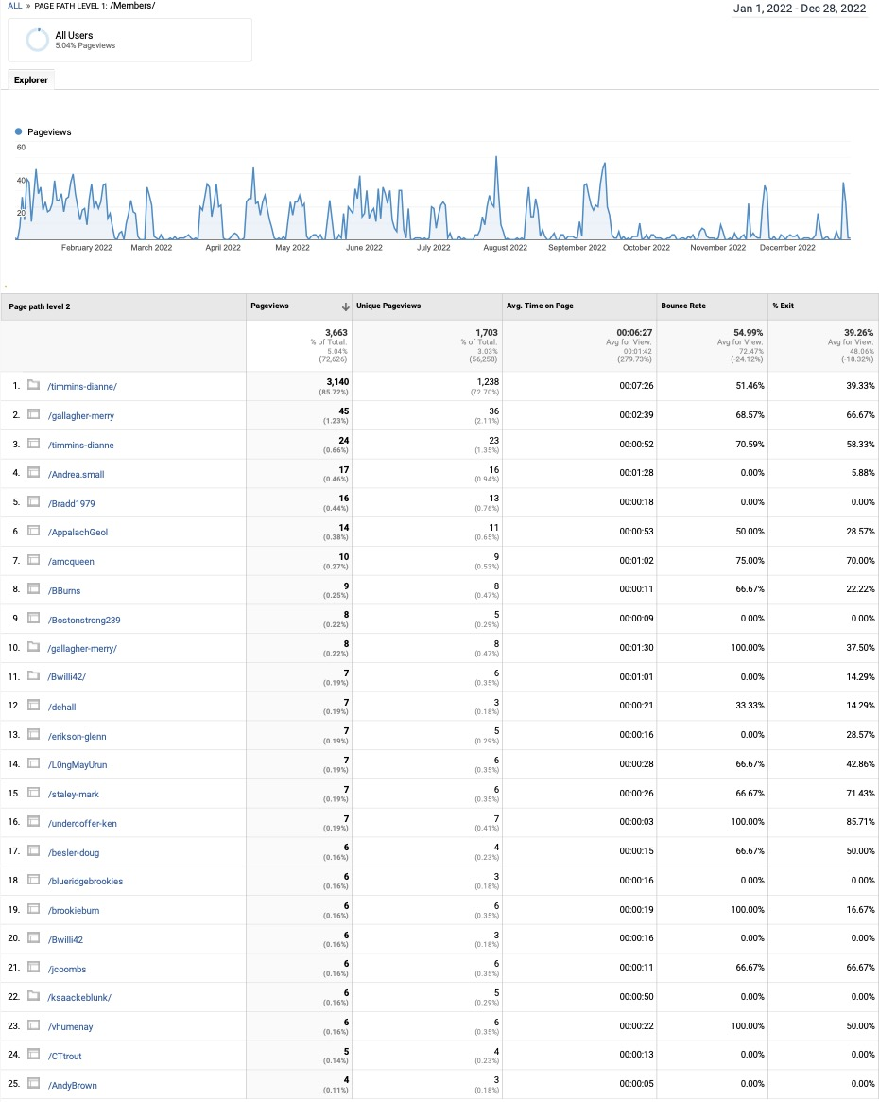

Top States
Region | Users | New Users | Sessions | Bounce Rate | Pages / Session | Avg. Session Duration
New York | 2519 | 2414 | 3143 | 73.75% | 2.00 | 115.63
Virginia | 1903 | 1832 | 2186 | 79.23% | 1.80 | 86.94
Massachusetts | 1825 | 1772 | 2237 | 71.66% | 2.08 | 118.62
Pennsylvania | 1714 | 1654 | 2191 | 68.69% | 2.33 | 113.29
Georgia | 1485 | 1416 | 1820 | 72.03% | 2.18 | 146.96
North Carolina | 1099 | 1053 | 1343 | 67.98% | 2.36 | 123.22
West Virginia | 891 | 856 | 1328 | 60.54% | 4.10 | 202.09
Ohio | 853 | 816 | 955 | 78.74% | 1.85 | 92.22
Washington | 806 | 802 | 820 | 81.83% | 1.32 | 9.55
Illinois | 804 | 795 | 872 | 91.86% | 1.22 | 18.74
Wyoming | 704 | 704 | 710 | 84.93% | 1.24 | 0.47
Connecticut | 696 | 663 | 805 | 75.28% | 1.95 | 86.87
(not set) | 688 | 682 | 726 | 92.70% | 1.12 | 6.40
Maryland | 677 | 652 | 1086 | 59.58% | 4.25 | 269.33
Florida | 605 | 563 | 680 | 78.82% | 1.80 | 72.62
New Jersey | 594 | 579 | 672 | 76.19% | 1.84 | 70.48
Tennessee | 592 | 565 | 720 | 74.03% | 1.94 | 88.67
Texas | 573 | 556 | 640 | 85.63% | 1.35 | 43.10
New Hampshire | 555 | 541 | 687 | 67.25% | 2.39 | 115.61
Maine | 525 | 509 | 1719 | 62.77% | 2.21 | 391.15
California | 436 | 423 | 477 | 83.44% | 1.58 | 48.03
District of Columbia | 385 | 349 | 441 | 70.98% | 2.39 | 103.30
Michigan | 337 | 302 | 369 | 75.34% | 1.80 | 128.48
Vermont | 335 | 319 | 422 | 70.85% | 2.16 | 93.09
South Carolina | 324 | 308 | 384 | 69.79% | 1.99 | 109.84
Colorado | 207 | 201 | 243 | 72.84% | 2.03 | 89.50
Indiana | 204 | 176 | 213 | 76.06% | 1.55 | 81.73
Wisconsin | 198 | 193 | 212 | 81.60% | 1.76 | 60.36
Alabama | 180 | 173 | 215 | 80.93% | 1.44 | 58.80
Rhode Island | 175 | 174 | 202 | 73.76% | 1.99 | 91.35
Kansas | 172 | 167 | 177 | 96.61% | 1.12 | 11.55
Minnesota | 140 | 137 | 161 | 78.26% | 1.60 | 84.88
Missouri | 134 | 129 | 147 | 81.63% | 1.52 | 47.73
Oregon | 126 | 120 | 151 | 78.15% | 1.50 | 48.75
Iowa | 124 | 123 | 130 | 92.31% | 1.25 | 19.24
Arizona | 121 | 118 | 138 | 75.36% | 1.65 | 61.94
Kentucky | 104 | 93 | 119 | 81.51% | 1.71 | 75.72
New Mexico | 97 | 90 | 244 | 47.95% | 11.20 | 364.45
Arkansas | 91 | 87 | 101 | 82.18% | 1.66 | 88.56
Oklahoma | 80 | 78 | 82 | 87.80% | 1.26 | 15.59
Louisiana | 78 | 76 | 80 | 85.00% | 1.25 | 33.60
Mississippi | 77 | 74 | 99 | 76.77% | 2.00 | 116.79
Utah | 69 | 68 | 73 | 82.19% | 1.38 | 39.25
Montana | 66 | 65 | 74 | 71.62% | 2.24 | 93.51
Idaho | 47 | 45 | 51 | 84.31% | 1.31 | 26.59
Delaware | 43 | 38 | 46 | 82.61% | 1.65 | 54.22
Nebraska | 40 | 36 | 41 | 78.05% | 1.83 | 83.51
Nevada | 36 | 32 | 41 | 78.05% | 1.44 | 124.24
Alaska | 22 | 21 | 25 | 72.00% | 1.76 | 71.44
Hawaii | 17 | 15 | 19 | 78.95% | 1.79 | 26.79
South Dakota | 14 | 12 | 14 | 78.57% | 1.36 | 102.86
North Dakota | 13 | 13 | 13 | 92.31% | 1.08 | 86.31
 | 24600 | 23679 | 30544 | 73.95% | 2.16 | 119.79

Top New York Cities
City | Users | New Users | Sessions | Bounce Rate | Pages / Session | Avg. Session Duration
New York | 1367 | 1298 | 1680 | 76.85% | 1.84 | 118.25
Scarsdale | 56 | 56 | 62 | 66.13% | 1.71 | 89.94
Buffalo | 48 | 44 | 52 | 80.77% | 1.54 | 68.60
Albany | 47 | 44 | 84 | 64.29% | 2.42 | 121.57
Syracuse | 38 | 38 | 46 | 69.57% | 1.87 | 60.89

Top Virginia Cities
City | Users | New Users | Sessions | Bounce Rate | Pages / Session | Avg. Session Duration
Ashburn | 702 | 684 | 733 | 90.31% | 1.34 | 44.57
Roanoke | 74 | 68 | 95 | 70.53% | 2.62 | 116.32
Richmond | 59 | 54 | 75 | 76.00% | 2.59 | 139.21
Virginia Beach | 56 | 55 | 62 | 66.13% | 2.23 | 191.35
Charlottesville | 45 | 44 | 50 | 82.00% | 1.24 | 54.24

Top Massachusetts Cities
City | Users | New Users | Sessions | Bounce Rate | Pages / Session | Avg. Session Duration
Boston | 470 | 444 | 579 | 73.40% | 1.87 | 142.36
Worcester | 44 | 44 | 52 | 69.23% | 2.02 | 114.31
Amherst | 36 | 34 | 40 | 57.50% | 2.38 | 124.28
Cambridge | 28 | 28 | 30 | 76.67% | 2.40 | 59.60
Chicopee | 25 | 23 | 29 | 75.86% | 1.62 | 62.14

Top Pennsylvania Cities
City | Users | New Users | Sessions | Bounce Rate | Pages / Session | Avg. Session Duration
Philadelphia | 272 | 257 | 320 | 76.88% | 1.75 | 78.98
Pittsburgh | 150 | 141 | 172 | 70.35% | 1.95 | 55.29
State College | 44 | 40 | 63 | 63.49% | 2.89 | 152.87
Harrisburg | 35 | 36 | 49 | 55.10% | 3.57 | 132.00
Erie | 21 | 20 | 23 | 69.57% | 2.43 | 149.48

Top Georgia Cities
City | Users | New Users | Sessions | Bounce Rate | Pages / Session | Avg. Session Duration
Atlanta | 575 | 536 | 702 | 73.36% | 1.93 | 157.98
Blue Ridge | 82 | 82 | 118 | 60.17% | 2.81 | 239.27
Athens | 58 | 55 | 70 | 77.14% | 1.90 | 83.57
Cumming | 20 | 17 | 22 | 77.27% | 1.50 | 45.14
Gainesville | 20 | 19 | 22 | 72.73% | 2.00 | 58.68

Top North Carolina Cities
City | Users | New Users | Sessions | Bounce Rate | Pages / Session | Avg. Session Duration
Charlotte | 153 | 146 | 175 | 72.57% | 1.84 | 86.99
Raleigh | 130 | 121 | 150 | 71.33% | 1.99 | 90.45
Asheville | 65 | 60 | 77 | 58.44% | 2.78 | 184.40
Boone | 50 | 50 | 74 | 51.35% | 3.42 | 167.55
Durham | 31 | 28 | 34 | 79.41% | 2.24 | 59.09

Top Referral Traffic
Source | Users | New Users | Sessions | Bounce Rate | Pages / Session | Avg. Session Duration
google | 17490 | 17153 | 21256 | 77.07% | 1.86 | 90.43
easternbrooktrout.org | 1179 | 794 | 1782 | 14.70% | 1.86 | 70.79
mytraffic.shop | 650 | 385 | 781 | 100.00% | 1.00 | 0.00
bing | 407 | 384 | 489 | 57.87% | 3.14 | 163.97
baidu.com | 150 | 150 | 150 | 100.00% | 1.00 | 0.00
duckduckgo.com | 133 | 131 | 162 | 61.11% | 2.98 | 165.96
m.facebook.com | 123 | 123 | 125 | 77.60% | 1.50 | 33.97
yahoo | 110 | 106 | 114 | 65.79% | 2.31 | 111.04
patrout.org | 77 | 73 | 90 | 54.44% | 3.69 | 186.51
classroom.google.com | 74 | 71 | 99 | 67.68% | 2.18 | 194.80
l.facebook.com | 65 | 56 | 181 | 25.41% | 7.24 | 409.69
landscapepartnership.org | 54 | 48 | 94 | 46.81% | 6.07 | 179.63
lm.facebook.com | 50 | 50 | 53 | 64.15% | 2.06 | 78.94
facebook.com | 39 | 39 | 40 | 97.50% | 1.03 | 0.25
paflyfish.com | 39 | 34 | 48 | 54.17% | 2.27 | 174.58
fishhabitat.org | 32 | 28 | 35 | 60.00% | 2.89 | 178.51
com.google.android.gm | 29 | 24 | 36 | 52.78% | 2.86 | 115.53
l.instagram.com | 24 | 22 | 137 | 18.25% | 12.91 | 847.48
youtube.com | 24 | 20 | 29 | 58.62% | 2.10 | 160.62
mail.google.com | 21 | 14 | 41 | 46.34% | 3.44 | 182.12
myemail.constantcontact.com | 21 | 18 | 24 | 87.50% | 1.50 | 41.79
ecosia.org | 15 | 14 | 77 | 37.66% | 9.95 | 460.73
nativefishcoalition.org | 15 | 14 | 15 | 73.33% | 1.67 | 36.47
app.asana.com | 14 | 6 | 30 | 13.33% | 13.43 | 926.70
ncwildlife.org | 13 | 12 | 28 | 46.43% | 2.50 | 60.82
 | 21118 | 20009 | 26389 | 71.56% | 2.08 | 99.33

