
EBTJV Stats Jan-Dec 2022
Contents
Landowner Resources Page Views Jan-Dec 2022 2
Are brook trout near me Page Views Jan-Dec 2022 3
Why Wild Brook Trout Content Drilldown Jan-Dec 2022 4
Landowner Resources Content Drilldown Jan-Dec 2022 5
Landowner Resources Locations 7
Are Brook Trout Near Me Locations 9

Landowner Resources Page Views Jan-Dec 2022
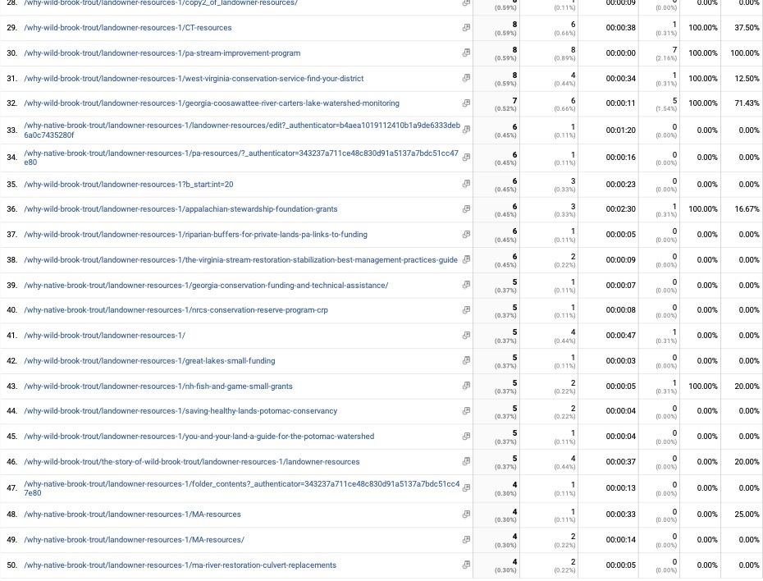

Are brook trout near me Page Views Jan-Dec 2022

Why Wild Brook Trout Content Drilldown Jan-Dec 2022

Landowner Resources Content Drilldown Jan-Dec 2022
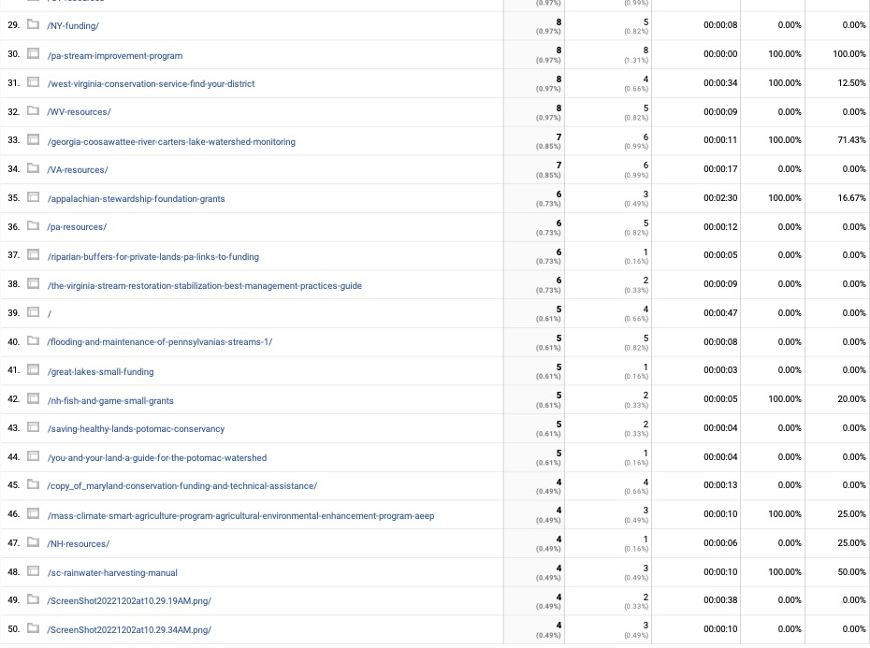

Landowner Resources Locations
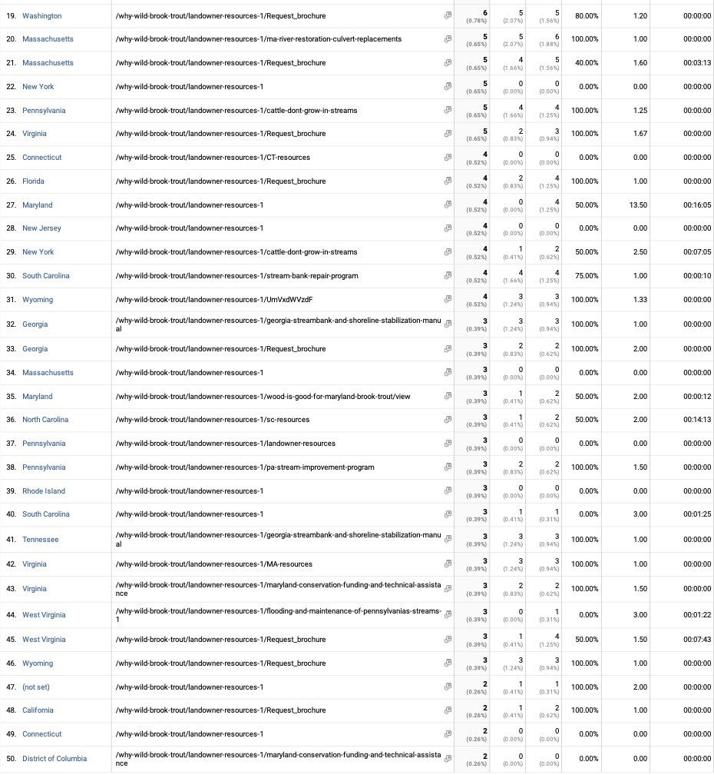

Are Brook Trout Near Me Locations
