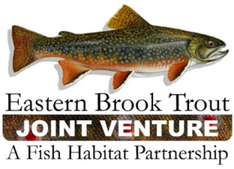
EBTJV Steering Committee Meeting Agenda
September 19, 2023 1-3pm ET

Zoom link (this is a change)
https://us06web.zoom.us/j/84101670719

- Steering Committee Roll Call (intros) & Establishment of Quorum (Jake Rash)
- Announcements
- Vote to approve the June 2023 SC meeting notes (Jake)
- Science and Data Committee
    - Catchment Updater Project update and reminders
- Habitat project RFP cycle status update (Lori)
    - Awareness, and opportunity to comment or join the review team
- Small grants for outreach and training (Lori)
    - Awareness, and opportunity to comment or join the review team
- NFHAP Update (Steve Perry)
- EBTJV annual meeting and operational planning (Lori)
    - Goals and expectations
    - Hiring a facilitator; review the funding source (this is a change from the proposal at the June meeting)
    - Review agenda and additional feedback
    - Review travel and reimbursement options
    - Who else should be invited?
- Member updates
    - Open time for project or initiative updates from any SC member
    - Future: tee up as a standing agenda item
- Other items/updates
    - Standing item: Reminder about science and data needs list
    - New: calendar for e-newsletters, soliciting content
    - If your email system filters managed listserves, please take a look at EBTJV's latest e-news
      - September 1: https://conta.cc/45BTEMU (link to new small grant for outreach and training)
      - August 23: https://conta.cc/3qHDhPK (contains a compilation of recent research and news items)

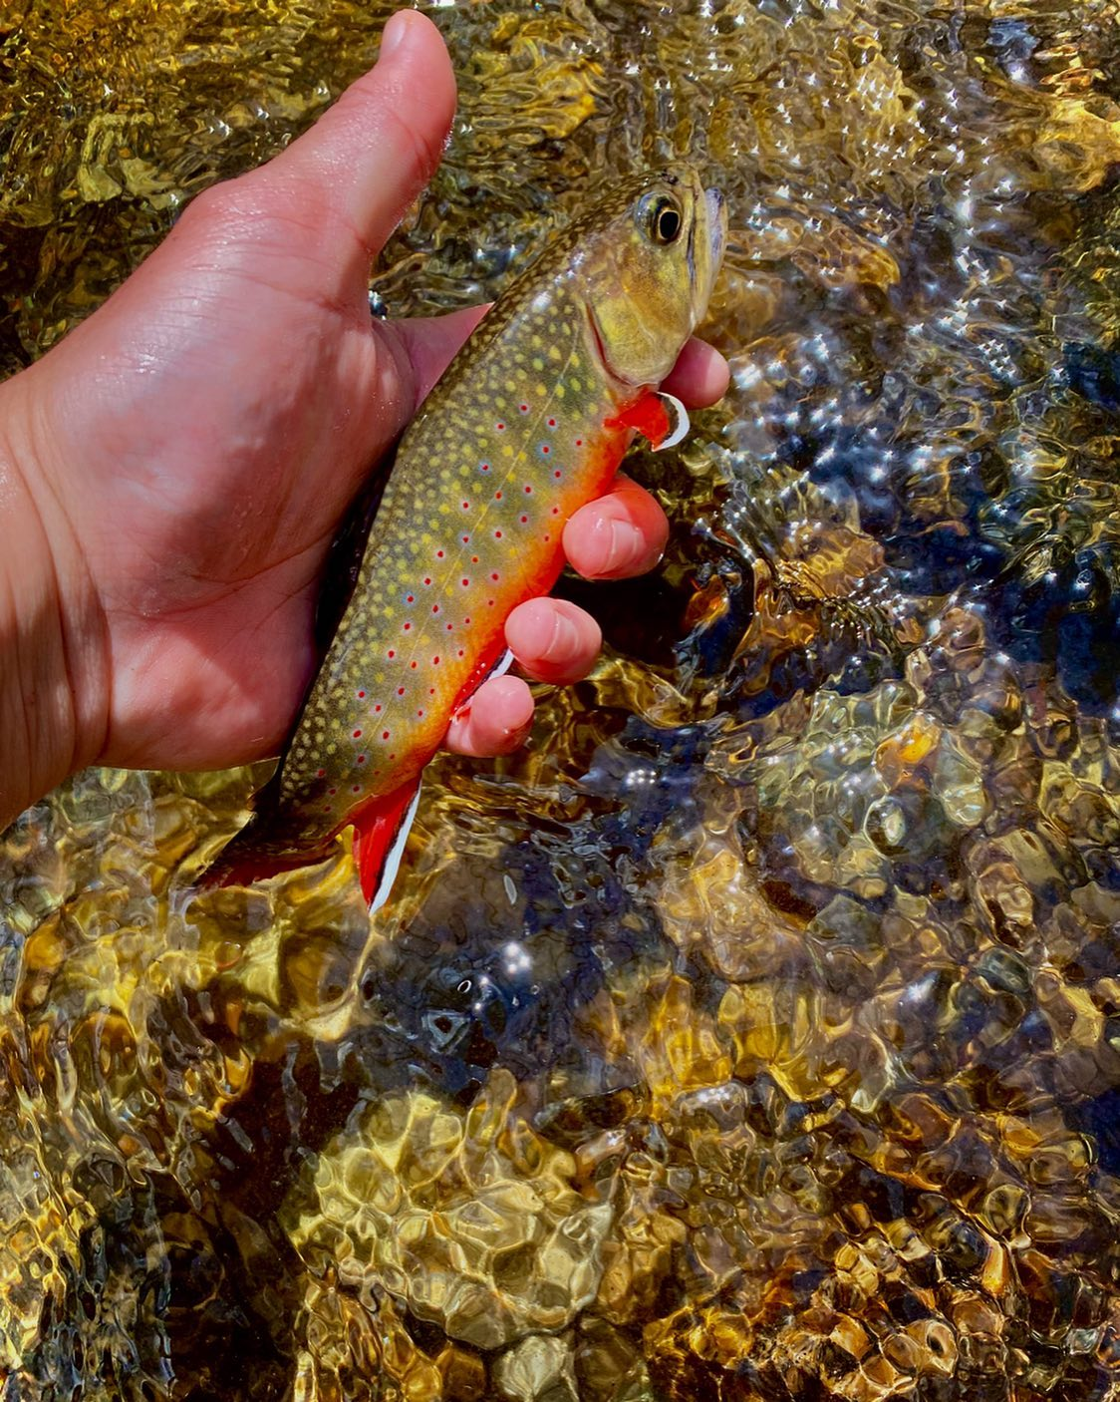

Photo shared on Instagram by an angler in the Carolinas. She is extremely grateful for the work that all of you do to protect these streams and the brook trout resources because they are a source of solace for her.

